

2017

AGEA CONSTRUCTION

4/1/2017

Design of a Highway Bridge

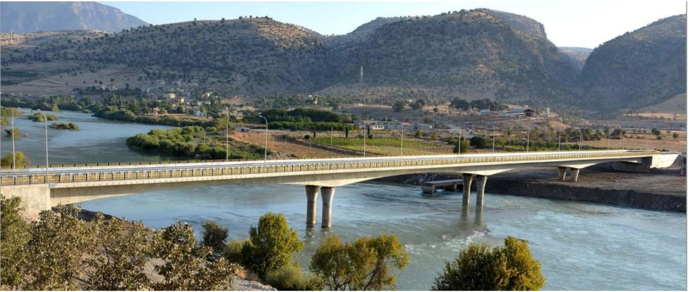

Table of Contents

1. Introduction and Description of the Project 3

2. Structural and Mechanical Features of Construction Techniques or Bridge Decks 6

3. Description of the Zuregvan Bridge. 11

4. Design Criteria and Work Procedures 18

4.1 Materials……………………………………………………………………………………………………………………18

4.2 Units………………………………………………………………………………………………………………………….19

4.3 General Informatıon on Design Criteria…………………………………………………………………….19

4.4 Design Process of a Bridge 21

4.4.2 Design Criteria of the Pier Columns 24

4.5 Live Load Criteria 24

4.6 Post-tensioning cables 26

4.7 Design of the Road Section 27

5. Structural Analysis and Design of Deck Component 29

5.1 General approach to the analysis and designwork………………………………………………….29

5.2 Design of the Deck Dross-section…………………………………………………………………………….29

5.3 Longitudinal and Sectional Features of the Deck Structure 37

5.4 Flexural moments affecting the deck and cable post-tensioning installation 43

6. Design and construction of piers 52

6.1 Construction of Piers………………………………………………………………………………………………….52

6.2 Earthquake 52

6.3 Column Design Considering Earthquake and Loads……………………………………………………58

7. Geotechnical Design 62

8. Aspects of Cost Estimation 71

9. References…………………………………………………………………………………………………………………….74

# Introduction and Description of the Project

**1.1 Main Definitions and Overview**

Bridge construction is one of the most ancient constructional achievements of mankind. From very early times of the history human being has needed individually or in group to gather foods on their trace they have needed to construct overpasses mostly medical use of dry tree trunk. In later periods stone, has started to be used especially in arch formed bridges in contemporary stage of bridge engineering, iron steel family materials have been used as well concrete family materials. Post-tensioned concrete which is the name of material also the type of construction method started to be used from late 19th century and was well developed during the last century. Our project group for the course CE410 has decided to concentrate on a contemporary Iraqi bridge with post-tensioned concrete material and processes. Both design and construction of facility has been led by Turkish companies, this fact constitutes an element of sympathy for this bridge and facilitates the process of getting information on this construction achievement.

**1.2 Bridge construction vs. New materials and techniques.**

It is well known that tensile strength of concrete is only about 10% of its compressive strength. As a result, plain concrete members are likely to crack when loaded. Reinforcing steel can be embedded in the concrete members to accept tensile stresses which plain concrete cannot resist. Reinforcing is selected assuming that the tensile zone of the concrete carries no load and that tensile stresses are resisted only by tensile forces in the reinforcing bars. Although the resulting reinforced concrete members may crack, still it can effectively carry the design loads. Starting from second half twentieth century there was a huge development and use of post tensioned concrete. Post-tensioned concrete bridges offer a broad range of engineering solutions and a variety of aesthetic opportunities. The function of prestressing is to place the concrete structure under compression in those regions where load causes tensile stress. Tension caused by applied loads will first have to cancel the compression induced by the prestressing before it can crack the concrete. Figure 1.1a shows a plainly reinforced concrete simple span beam and fixed cantilever beam cracked under applied load. Figure 1.1b shows the same unloaded beams with prestressing forces applied by stressing post-tensioning tendons. By placing the prestressing low in the simple-span beam and high in the cantilever beam, compression is induced in the tension zones; creating upward camber.

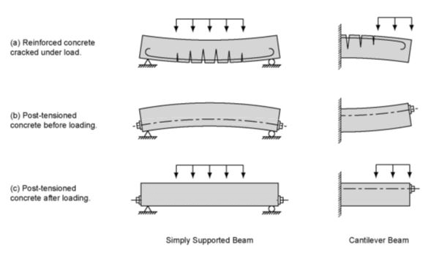

*Figure 1.1 - Comparison of Reinforced and Prestressed Concrete Beams*

Figure 1.1c shows the two prestressed beams under the action of post-tensioning and applied loads. The loads cause both the simple-span beam and cantilever beam to deflect down, creating tensile stresses in the bottom of the simple-span beam and top of the cantilever beam. The designer balances the effects of load and prestressing in such a way that tension from the loading is compensated by compression caused by the prestressing. Tension is eliminated under the combination of the two and tension cracks are prevented. As a result, durability is increased and more efficient, cost effective construction is realized.

Prestressing can be applied to concrete members in two ways, by pretensioning or post-tensioning. In pretension members, the prestressing strands are tensioned against restraining bulkheads before the concrete is cast. After concrete has been placed, allowed to harden and attain sufficient strength, the strands are released and their force is transferred to the concrete member. Prestressing by post-tensioning involves installing and stressing prestressing strand or bar tendons after the concrete has been placed, hardened and attained a minimum compressive strength for that transfer.

Compressive forces are induced in a concrete structure by tensioning steel tendons comprised of strands or bars placed in ducts embedded in the concrete. The tendons are installed after the concrete has been placed and sufficiently cured to a prescribed initial compressive strength. A hydraulic jack is attached to one or both ends of the tendon and pressurized to a predetermined value while bearing against the end of the concrete beam. This induces a predetermined force in the tendon and the tendon elongates elastically under this force. After jacking to the full required force, the force in the tendon is transferred from the jack to the end anchorage.

Tendons made up of strands are secured by steel wedges that grip each strand and seat firmly in a wedge plate. The wedge plate itself carries all the strands and bears on a steel anchorage. The anchorage may be a simple steel bearing plate or may be a special casting with two or three concentric bearing surfaces that transfer the tendon force to the concrete. Bar tendons are usually threaded and anchored by means of spherical nuts that bear against a square or rectangular bearing plate cast into the concrete.

The protruding “tails” of strands or bars of permanent tendons are cut off using an abrasive disc saw or plasma cutting after stressing. Flame cutting should not be used as it negatively affects the characteristics of the prestressing steel. Tendons are then grouted using a cementitious based grout. This grout is pumped through a grout inlet into the duct by means of a grout pump.

**1.3 Brief Description of the Structure Studied as Case of the Project Work**

The structure which is taken case study is located on the Great Zab River in Iraq. The total length of the bridge is 240m including connection roads. It is required to construct the bridge with 4 spans, each span length is 60, and 3 piers which average height is 10m. Bridge layout plan is shown in the figure 1.3.1

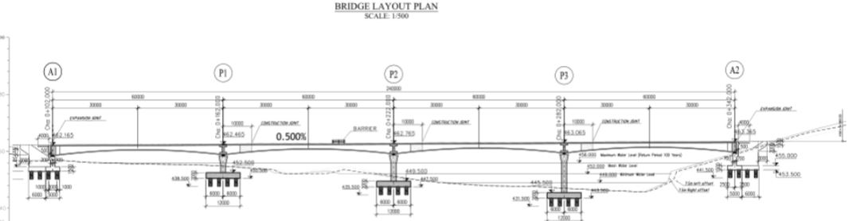

*figure 1.3.1*

The bridge has two lines (one line for each direction). The width of the bridge deck slab is 15 m. The width of the border is 6 m (3 meters for both sides of the bridge). Cross section dimensions of the span is changing from support to midspan (figure 1.3.2).

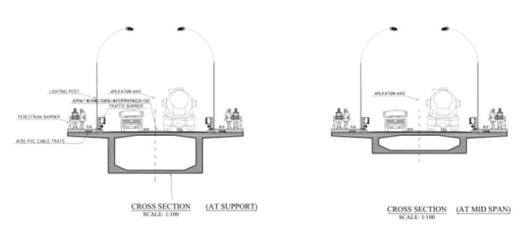

*figure 1.3.2*

The bridge was built by Scaffolding Method. The main reason of using this method is geography of the construction zone. The shallow valley having an average depth of 10 meters makes it reasonable in terms of economic goals. This will be widely explained in the next chapter.

# Structural and Mechanical Features of Construction Techniques or Bridge Decks

**2.1 Historical Reviews of Bridge Construction Techniques.**

Glimpsing back to the history of bridge construction one can see that in early days bridges were constructed by the means of masonry and stone crafting. Still most of them were durable and strong enough and preserved to our times. They were generally built as viaducts with relatively short spans as the strength of the stones allow. The most well-known of this bridges can be considered as Buyukcekmece bridge in Edirne which was constructed by Mimar Sinan by the order of Kanuni Sultan Suleyman, which is still under service. The bridges were constructed from materials like timber and later from mainly steel components. In our days starting from the early periods of the last century new materials and fitting techniques started to be used in bridge construction. Materials like reinforced concrete and tension cables were used and for relatively big spans, the girders of the bridge were hanged from the cables. Spans became wider and wider so the steel material used extensively as deck material and piers were made of reinforced concrete. Although the concrete is the most widely used material in construction the bridge deck was additionally reinforced by tension cables across the length to provide better tensile strength for the loads. However, for small spans still the reinforced concrete is used. One of the most beneficial innovation in bridge construction came with fabrication of prestressed concrete elements and its technology. From it the post tensioning technique derived for larger spans. Bridges and viaducts became able to carry heavier loads as machinery and railways thanks to this invention. The technique first started to be utilized across the Europe and USA. Nowadays nearly every bridge constructed it being traffic joints or over river, valley bridges benefit from posttensioning and pretensioning technology.

The origin of reinforced concrete bridge construction in the United States dates back to 1889 with the construction of the Alvord Lake Bridge in San Francisco, California. Though many advancements have been made, basic features of construction remain unchanged. The work requires construction of formwork to contain and provide shape to the wet concrete. Formwork is supported by falsework either resting on the ground or on prepared foundations, until the structure itself is self-supporting and formwork and/or falsework can be removed. Unfortunately, bridges constructed with reinforced concrete are only economical for relatively short spans. Superstructure types include flat slabs, beam with slabs, and box girders. At the time, longer spans were achieved by using arch construction.

Reinforced concrete box girder bridge construction flourished in the western part of the United States as a result of economy and local contractor experience. The California Department of Transportation (Caltrans) began constructing box girder bridges in the early 1950’s. With the popularization of prestressed concrete technology in the early 1960’s, Caltrans realized further economy through the construction of many post-tensioned concrete box girder bridges. Refinements to post-tensioned box girder bridge construction continued throughout the United States in the second half of the 20th century.

Turkish construction companies and contractors started to use this technology several years ago. French Freyssinet and Turkish Freysas venture carried out works on many important bridges in Turkey and can be considered as pioneers in this sector. The most recent examples in which they had a contribution can be considered as “Yavuz Sultan Selim” bridge in Istanbul, also known as 3rd bridge. The post tensioning system Diwidak used in some projects in Turkey

**2.2 Different Procedures for Construction of Post-Tensioned Concrete Decks.**

Here I want to mention the most commonly used techniques of bridge construction. In our days there mainly 3 different methods for post-tensioned decks and one for pre-tensioned precast decks construction.

**2.2.1 Scaffolding Method- Scaffoldings Resting on Land Method.**

Fourth and again widely used methods are the one where concrete is cast in-situ and tensioning is carried out on the place, it is referred to as scaffolding method. This method is generally preferred when the valley or the river bed is not so deep and wide. Scaffoldings and other similar equipment can be used here. ØIn the end the tensioning of internal cables is carried out once more so that the overall structure will acquire its final design or service strength. This is the method that was used in the construction of Zuregvan Bridge over Zab River. It should be mentioned that this technique was the preferred and adopted technique for our case study bridge

**2.2.2 Segmental Method ( Balanced Cantilever Deck Segments)**

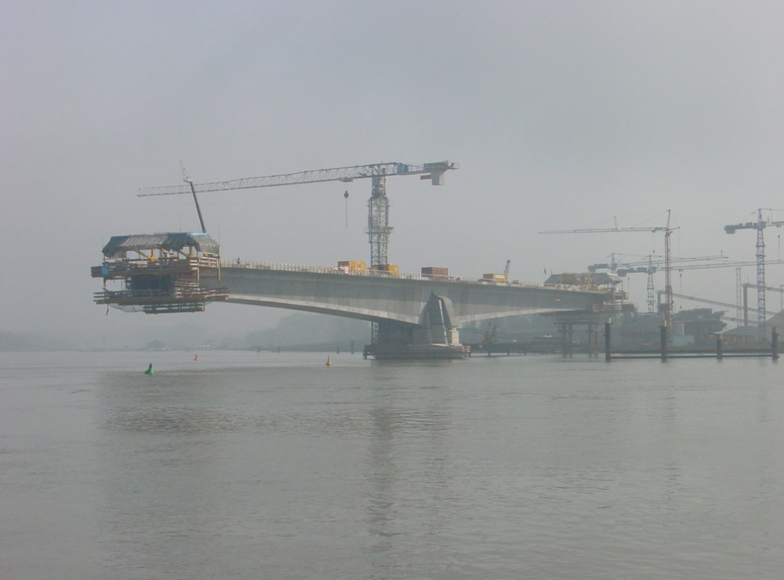 Here comes the segmental method of construction. In this particular technique, the scaffolding is installed for the first span and cables are installed along with reinforcement and concrete is cast. After the hardening of concrete element and its tensioning the scaffoldings are transferred to the other span by means of moving rails, that is, scaffolding under the bridge is mobile. So it continues until the end of construction. This method also called cast in place segmental method. It is generally preferred for large and relatively deep valleys.

Figure 2.2.2.1 :An example for segmental cantilever method

**2.2.3 Incremental Launching Method.**

The second method is incremental launching method where one casts the concrete in the special area on site and the tensioning operation is carried out. The ready block, that is set and hardened and which developed enough stress is pushed by little amounts to its place by the use of special equipment and machinery. The other girders follow it by through the same procedure over each other. This method is preferred if the valley is big and deep thus making it hard or impractical to rise a scaffolding. When the bridge is too long the builders start to incrementally

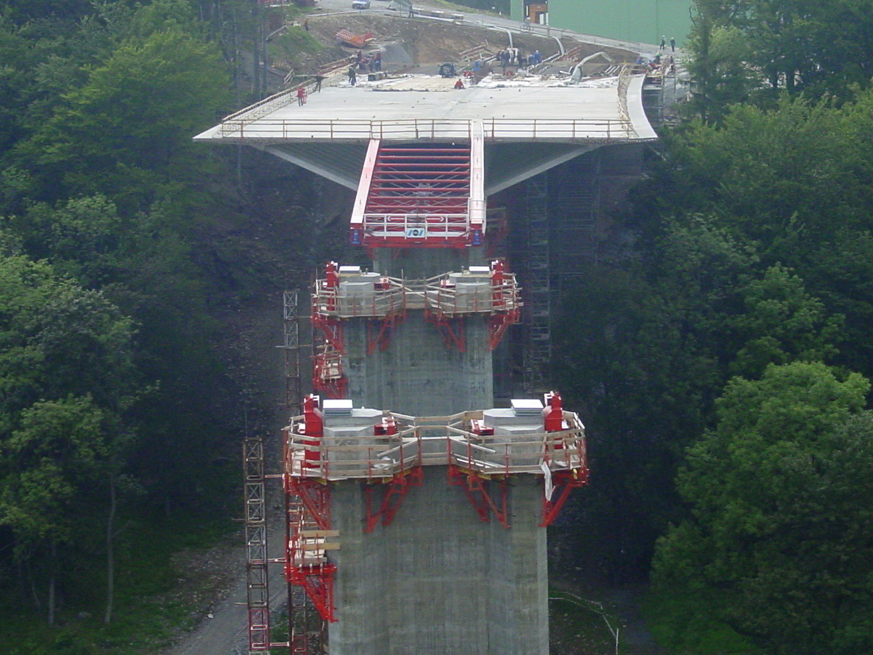launch the blocks from each end until they meet somewhere in the middle.

Figure 2.2.3.1: A good example of incremental launching method in deep and forested valley.

**2.2.4 Making use of precast presstressed beams .**

The first one will be the precast and presstressed concrete elements method, where one casts concrete on top of the already put together reinforcement and cables. Then settled and hardened concrete goes under tension which is applied by means of cable with special equipment. Thus internal compressive stresses are created in concrete because of tension in the cables. Here adherence between cables and concrete plays an important role in the development of these stresses. These operations are carried out in some other place and these blocks are carried to the site where they will be installed to their places according to design. So the other elements are installed until all the spans are ready.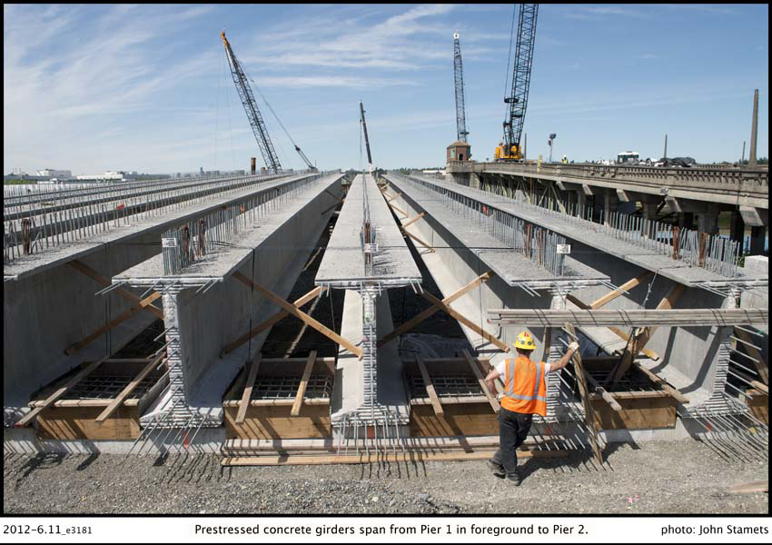

Figure 2.2.4.1: Prestressed concrete girders span from Pier 1 in foreground to Pier 2.(Photo by John Stamets, courtesy of King County DOT)

Structural features of the application of these techniques in Zuregvan Bridge are going to be retaken in the following chapters concentrated on analysis and design. Priority would be given to the procedure of making use scaffolding systems resting on soil and supporting the formworks since this is the technique used in studied Zuregvan bridge.

# Description of the Zuregvan Bridge.

**3.1 Geographical Situation**

Zuregvan Bridge which is situated on the great zap river that flows through turkey and Iraq, the Kurdish governorate of Iraq to be exact, was constructed due to various needs that will be mentioned in this chapter. The main reason behind its construction can be considered as its importance on logistics and transportation necessity at the region of Iraq. Geographically the Zab River starts its origin from the van region in Turkey. Then it continues through Hakkari region and through Iraq joins the great Tigris River which is more of a well-known river than Zab due to its historical importance. Everybody who took history classes must have heard Tigris rivers name at least once for sure. The Zab can be considered as biggest tributary that joins the Tigris. Also, the river is close to the Barzani’s village, who is the head of Kurdish state in Iraq, thus making it politically important too. Nonetheless, its geographical importance cannot be ignored. As it is well known humankind first started to settle near the river banks or sweet water shores as soon as he abandoned the nomad and hunter gatherer type of existence. Cultivation was the reason behind the humans settling and abandoning nomad life. Zab River was one of those where humans found shelter.

For our days, the river gained much importance because of high tension in the Iraqi region. Since previous bridge was destroyed during the clash between some of those minorities that occupy the region. Zab also serves as boundary between Erbil governorate and Ninawa governorate. Current bridge was constructed by Turkish design companies and contractor. As it is well known Turkish contractors and design companies carry out many important projects around the world especially in Middle Eastern region and post-soviet states. So, it is not a matter of surprise that the bridge was constructed by them. The exact geographical location of the bridge is somewhere near the Kandil Mountains and near the fore mentioned Barzani’s village. The channel of the bridge is not so wide and can be considered as narrow. The main characteristic of the bridge is that it was build using the post tensioning technique. This technique consists of casting the concrete by the use of scaffolding in-situ and then applying the post tensioning to the cables installed in the reinforced concrete mass. This operation was carried out by French “Freyssinet” and Turkish “Freysaş” venture. The company that carried out general construction works is a turkish contractor company called “HGG”. This particular operation required high Professional knowledge about the post tensioning and strict supervision of the Project, since these post tensioned cables will carry nearly all service load during the bridges lifetime. The idea of using this technology comes from its practicability in this kind of projects and since traditional prestressed and precast concrete technique is not suitable for use there because the bridges girder spans are 60 meters, it is not practical and somehow challenging to transport the precast concrete elements for installation. Preparing the formwork and scaffolding, then casting the concrete followed by its post-tensioning is more suitable. İt also preffered over the incremental launching method since the valley or the river bed is not so deep and wide.

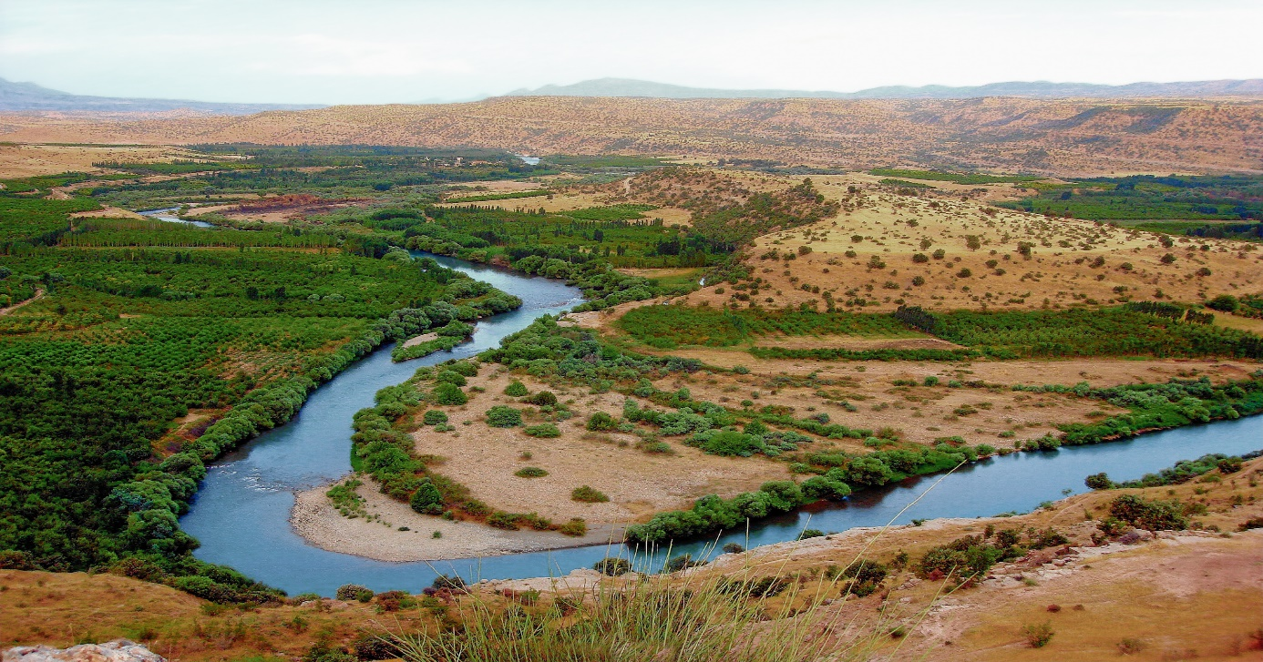

Figure 3.1: The Zab river valley

**3.2 Technical and administrative Steps of the construction operation**

Coming to the companies which had a hand on the bridges construction. Freyssinet is one of the leading French design and construction companies which main activity is in bridge construction area. Founded over 70 years ago by Eugène Freyssinet, the inventor of prestressing, Freyssinet brings together an unrivalled range of skills in the specialist civil engineering sector, offering integrated technical solutions in the fields of construction and structural repair. Freyssinet is involved in numerous projects across five continents. The fields they have gotten expertise are: prestressing; construction methods; structural accessories; structural repair and reinforcement; structural maintenance.   
These activities are performed on a wide range of structures, including civil engineering structures, buildings, skyscrapers, industrial installations, power production plants, offshore platforms, transport and sporting infrastructure, and more.

Freysaş group was founded at 1988 by the Vinci Corporation that owns the Freyssinet and Yapi merkezi partnership and considered as one of the pioneer and qualified institutions in the field of modern structural practices and structural element production. Their area of operation consists of Middle Eastern and eastern European regions. The Zuregvan Bridge was constructed by the collaboration of the two companies Freyssinet and Freysas. As the posttensioning is crucial part of the bridge construction it can be stated that client knew to whom trust this job.

**3.3 Technical particularities of the Zuregvan Bridge**

Coming to the particular construction technique applied in “Zuregvan” bridge, we can say following things. The Zab River has a width exceeding 200 meters in the geography of construction region. This is a shallow valley having a depth of 10 meters in average varying from 5 meters to 15 meters. Very shallow parts of the valley used to be dried during 3-4 months of the summer season, this foot has constituted a big practical advantage for construction of footings and piers easily and rapidly almost 3 spanning length of the deck area had this advantage while the remaining 50-60 meters of valley was showing a deeper geometry where the water flow was continuous during the year.

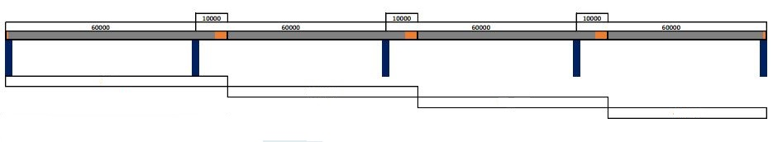

Figure 3.2: Scaffolding method resting on lands method schematic

**3.4 Overall information on the construction operations**

Construction of footings and piers staying in this part of river required special precautions. Formation of some artificial islands was necessary to facilitate the construction of footings and piers in this part of the river. Thanks to this land filling in the river to create artificial isles a dried surface is obtainable and construction of footings and piers for this last span would be possible. During this operation flow of water would be around the artificial island and whole flowing region of the river would not be disturbed too much. At the end of this operations the filled earth portions are taken from the filling area and moved to various parts of the river.

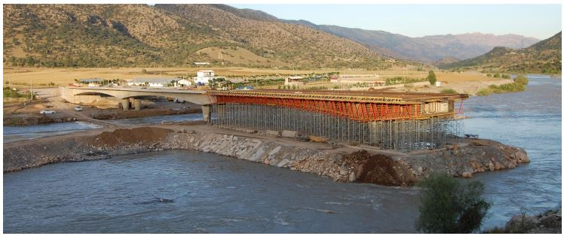

Figure 3.4: “Zuregvan” bridge constructed by scaffolding method

**3.5 Cross Sectional Properties of the Deck**

As previously mentioned the post tensioned bridge cross section is of a box girder with a hollow middle part. It can be multi cell or single cell depending on the architectural and structural needs. Indeed, these sectional differences are of general order. For each bridge case and situation some variations should be expected. In our case, the box given in the Figure 2.7 would have different thickness values ensuring the change of moment of inertia which would be needed to have different values at the mid span and the support. This is a necessity and unavoidable result of the longitudinal structural behavior of the bridge deck. As shown in Figure 2.5.

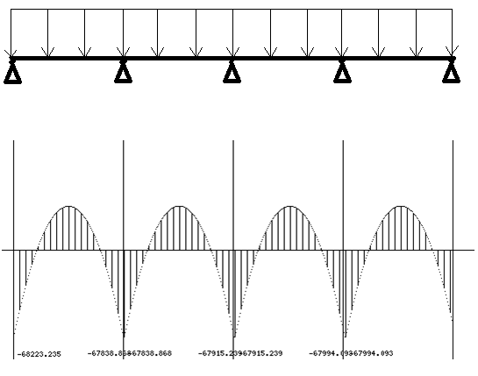

Figure 3.4: Moment diagram of the four span bridge

Support level longitudinal flexural moments are higher than mid-level flexural moments. This would lead to the requirement of stronger and more massive cross sectional values at the supports than of the mid-span. Practically speaking, there are two ways to ensure the change of structural system values and moments of inertia. One would be to change the value of depth of the cross section from the support to the mid-span. Second way is to ensure increase the moment of inertia at support level is to play with thicknesses at web and upper slab portion of cross section. In the second approach, it is easier from construction practice point of view and it is more often preferred for the discussed situation as in the case of “Zuregvan” bridge.

As it had been underlined in previous chapters the deck of the bridge has the length of 240 m composed by 4 portions each longing 60 m



Figure 2.6: Multi cell box girder



Figure 3.5: Single cell box girder cross section

The basic components of the cross section are:

• Top slab—the entire width of concrete deck, including the portions between the webs and the overhangs outside of the webs.

• Overhangs (cantilever wings) —the overhanging portion of the top slab.

• Webs—vertical or inclined, exterior or interior.

• Bottom slab.

The cross section that was used in our bridge is the single cell one. One of the differences which our bridge possesses is that it has got blisters on the lower sides of the hollow section which provides additional tensional strength for the bridge. The post tension cables are also installed in blisters. 2 earthquake energy dissipating elements are installed in between the girder and the pier. These energy dissipaters are crucial part of the contemporary bridge construction techniques since designers started to get more and more aware of the possible damage that can be caused by even small scale earthquake, which can for sure affect the service life of the structure even if not immediately but in the long run. From the afore mentioned words it can be derived that the total deck span is continuous, however total structure is not, due to this transition zone between the pier and the deck where energy dissipaters are installed. In the following chapters characteristics of the reinforced concrete and tension cables that were used in bridge will be discussed in more detail.

# Design Criteria and Work Procedures

**4.1 Materials**

Following materials were used during the construction of bridge

Concrete grade for deck C50

Concrete for columns C50

Concrete for foundation C35

S420 reinforcement steel

Post-tension cable 1387.5MPa (with 75% efficiency)

Post-tension cable type 19c15

**4.2 Units**

Length mm, m

Forces N, kN, MN

Stresses MPa, KPa

Moments kNm, MNm

**4.3 General Information on Design Criteria**

Zuregvan Bridge is designed by Mega Engineering Consulting Company. Construction related work carried out by HGG Construction Inc. Post-tensioning is carried out by Fressinet, Turkish Freysas venture. We have visited Mega Engineering and Consulting Company and they have shared their knowledge and information which is related with the Zuregvan Bridge with our group. They sent some files which is related with Zuregvan Bridge design to us in order to guide us in our design process. These files contain following files;

-AASTO LRFD Design Specifications

-5 bore log data which classifies soil related properties up to 30 m.

-Post Tensioning Tendon Installation and Grouting Manual

-Post-Tensioned Box Girder Design Manual

-A Table which Represents Traditional Minimum Depths for Constant Depth Superstructures

-Some basic information states lane number in the road, bridge deck slab width, curb width, thickness of asphalt pavement, load of pedestrian guard rail, load of road railing, temperature changes regarding load and relative humidity.

-Top and side profiles of Zuregvan Bridge Area with contour lines in AutoCAD file.

-Agreed dimensions of the Zuregvan Bridge (only top look).

-Manual of Construction Stage Analysis for FSM (Full Staging Method) Using General Functions

-An example looks of bridge with Midas computer program with a .mcb extension.

-Geotechnical report of Zuregvan Bridge.

-Fressinet Prestressing, the system of prestressed concrete manual.

Although these files are given to our group, they were only a guideline for us. Some of them are only guidelines for fundamentals of bridge design. So, our main goal here is to design by ourselves and comparing these results with actual design report to see whether results are logical or not.

The bridge was constructed in 4 stages. First step we put scaffolding for 70m. Between two piers we have 60m empty space. From our structure knowledge, we know that around L/5 the moment is zero. There we can connect post-tension cables in moment zero zones. For sake of simplicity we extend our span 10m after piers. Maximum moments occur in piers and half of maximum moment occur in spans. The pedestrian load is calculated with 100 kg/m and the car load is calculated 400 kg/m. In total we have 500 kg/m live load. Design of bridges there is two sources we got help from; AASHTO LRFD Bridge design specification and Eurocode. Eurocode is simpler and units are same with our country. For designing deck height we used formula for must suitable and accepted formula which is length over 15m so we found that our deck height must not be less than 2.5m.The following table derived from AASHTO and says our beam height and widening limits. The width is equal to 15m.The pedestrian area is 2.5 m both sides. 2 lane roadway with 10m, 6 cm of asphalt is taken for dead load calculation. The bridge is in 3rd zone of earthquake territory. The bridge can have vertical load. To lower earthquake forces the spans has earthquake supports at ends and isolators on columns where span touches.

## 4.4 Design Process of a Bridge

From the beginning of mankind, humans tend to go from somewhere to somewhere else. Humans need transportation by their nature. Sometimes they have tried to transport some goods or they had to go someplace to another. For this reason, they started to move. With time, this needs evolved to more complicated needs. They did want to go faster and more safely, so they have constructed the roads. One final need was to cross wide openings; they did not want to move around the longer paths. Therefore, bridges have to be constructed for their needs. With time they started to construct more sophisticated and complex bridges. Then process is standardized with time, technology and knowledge.

In our time, everything is restricted with some codes or standards. There are a number of design codes which states many features of bridges. Design process of a bridge is complicated and has many variables; these variables should be taken into consideration in so many ways. Any mistake can cause to catastrophic effects. Many examples can be found in history. Nevertheless, if below design procedures taken to consideration, failure probability will be significantly decreased. To design steps would comprise the following activities.

Designing group should be in regular communication with the administration authorities and also construction groups.

Above, there are listed all the steps of constructing a bridge. All are not related with design, yet they are all crucial for a safe building. Above list should be carefully examined and should be applied when constructing the bridge or some other structure. In our case only preliminary and detailed design is applicable.

For our case, AASHTO codes will be our guide for the design of deck and bridge overall.

The work carried out by our group consisted to redesign the bridge considering all of the above standards and manuals. Indeed, spans, the height of piers, the form of deck, have been chosen considering geographical features of Zap River. So these aspects will not be changed and we will stick to the original design parameters which is made by professional engineers. Therefore, geographical features are going to be kept while designing the bridge. However, deck design will be remade from the beginning. The information to be obtained from Mega engineering office is going to be limited to external sizes.

**4.4.1. Deck Design Criteria**

In order to design the deck, starting from the geometry of the deck, continuing with design specifications, materials, details of reinforcements, limit state design; loads etc. are taking into consideration. Design is made regarding every possible outcome.

Deck design will be followed by cable (tendon design), after that bridge foots will be designed according to deck’s geometry. Foundation related design will be made according to superstructure properties.

*Table 4.4.1- Traditional T Minimum Depths for Constant Depth Superstructures*

|  |  |  |  |  |  |  |
| --- | --- | --- | --- | --- | --- | --- |
| Superstructure | | Minimum Depth (Including Deck)  When variable depth members are used, values may be adjusted to account for changes in relative stiffness of positive and negative moment sections | | | | |
| Material | Type |  | | Simple Spans | Continuous Spans | |
| Reinforced Concrete | Slabs with main reinforcement parallel to traffic | 1.2 (S +10)  30 | | | *S* + 10 0.165m  30 | |
| T-Beams | 0.070L | | | *0.065L* | |
| Box Beams | *0.060L* | | |  | *0.055L* |
| Pedestrian Structure Beams |  | *0.035L* | | *0.033L* | |
|  | Slabs |  | *0.030L* > 0.165m | | *0.027L* > 0.165m | |
| CIP Box Beams | *0.045L* | | | *0.040L* | |
| Precast I-Beams | *0.045L* | | | *0.040L* | |
| Pedestrian Structure Beams | *0.033L* | | | *0.030L* | |
| Adjacent Box Beams | *0.030L* | | | *0.025L* | |
| Steel | Overall Depth of Composite I-Beam | *0.040L* | | | 0.012L | |
| Depth of I-Beam Portion of Composite I-Beam | *0.033L* | | | 0.027L | |
| Trusses | O.lOOL | | | O. l OOL | |
|  |  |  | | |  | |

## 4.4.2 Design Criteria of the Pier Columns

It is foretold that in the design of the columns, dimensions are determined according to the views of experienced authorities and design dimensions of the previous similar projects. At the point the primary concern was to build an approximate pier column which would be able to manage to stand high-scaled moment forces occurred by the earthquake and vehicular loads. The compression force by the load of the bridge was not a concern about determining the dimensions, because for carrying the bulk weight of the bridge deck, the necessary cross-section area was significantly smaller.

## 4.5 Live Load Criteria

Study of flexural and shear effects created by the mobile loads on the bridge decks is a topic presenting uncertainties. International standards and codes do define loading patterns in such a way that location of loads have different values. Indeed from point of view engineering practice, experienced designers have rather the tendency of opting a physical situation practically most applicable. In our study, considering the subjections of some experienced designers have concentrated on two different patterns. First pattern was based ın the description of the Midas Computer Program. As a second alternative we have considered suggestions of Civil Engineering Design Course project advisors, a number of vehicles acting on a given time on the bridge altogether.

Technical University, the heavy vehicle single loads and sizes have been taken based on the findings of recently completed research report for which General Directorate of Highways of Turkey has acted under consideration of “client” and METU was responsible of the running of scientific and technical aspects of research. On the other hand, heavy truck loads are considered as acting only on one line of the road in each direction. The second lane will be occupied by the small lighter vehicles which could create a distributed load of 2.5 kN per meter. The heavy vehicle is taken as AYK-45 truck and the loading of the truck is given below.

Figure 4.2.1: AYK-45 Truck loading



In the loading consideration, 2 different sources were used as stated. First is the analyses done by MIDAS computer program which uses AASHTO standards. The second consideration is based on engineering judgment to create the most critical loading cases, namely, trucks following each other with 30 meters between them along various spans at different times. Also, trucks following each other with 37.5 meters between them which is approximately 2.5 truck lengths are considered due to the suggestions. However since a distance of 30 meters which is 2 trucks lengths of difference between each truck is found critical and used.

## 4.6 Post-tensioning cables

Strands for post-tensioning are made of high tensile strength steel wire conforming to ASTM A416. A strand is comprised of 7 individual wires, with six wires helically wound to a long pitch around a center “king” wire. Strand is most commonly available in two nominal sizes, 0.5 inch and 0.6 inch diameter, with nominal cross-sectional areas of 0.153 in2 and 0.217 in2, respectively. Though the majority of post-tensioning hardware and stressing equipment is based on these sizes, the use of 0.62 inch diameter strand has been increasing.

Strand size tolerances may result in strands being manufactured consistently smaller than, or larger than nominal values. Recognizing this, “Acceptance Standards for Post-Tensioning Systems” (Post-Tensioning Institute, 1998) refers to the “Minimum Ultimate Tensile Strength,” which is the minimum specified breaking force for a strand. Strand size tolerance may also affect strand-wedge action leading to possible wedge slip if the wedges and strands are at opposite ends of the size tolerance range.

Strand conforming to ASTM A416 is relatively resistant to stress corrosion and hydrogen embrittlement due to the cold drawing process. However, since susceptibility to corrosion increases with increasing tensile strength, caution is necessary if strand is exposed to corrosive conditions such as marine environments and solutions containing chloride or sulfate, phosphate, nitrate ions or similar. Consequently, ASTM A416 requires proper protection of strand throughout manufacture, shipping and handling. Protection during the project, before and after installation, should be specified in project drawings and specifications.



*Figure 4.5.2: The Anchor Placement Criteria*

*Figure 4.5.1: Freyssinet C-Range Tendons*

## *Figure 4.5.3: Height and Width of Anchor Plates*



*Figure 4.5.4: a and b Values for Different Tendon Types*

**4.7 Design of the Road Section**

For the road build on the bridge deck, the width of the deck is given 15 meter long. By taking the specifications of General Directorate of Highways of Turkey, the lane placement is designed as it is illustrated below.

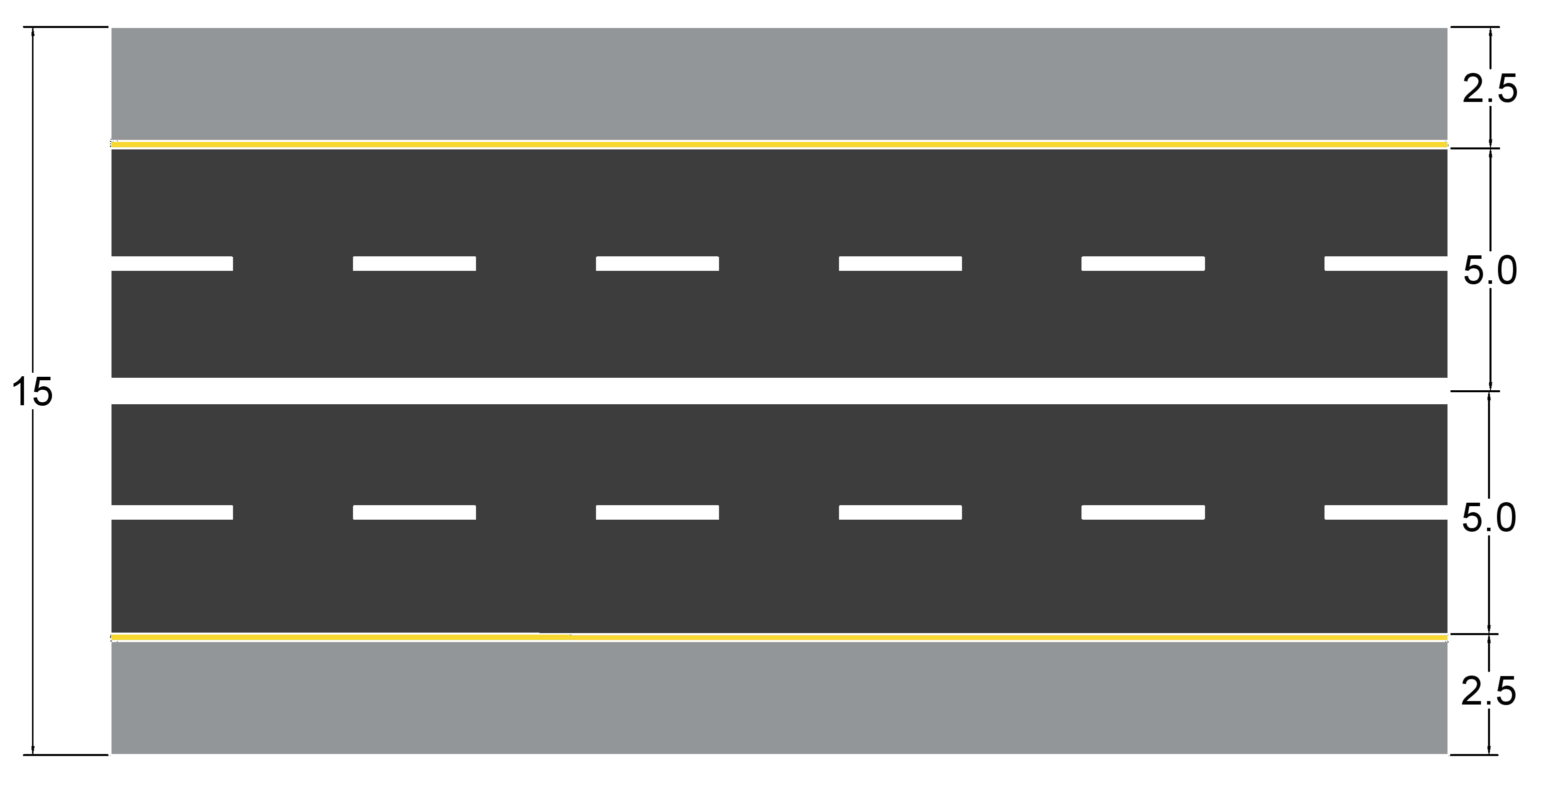

*Figure 4.5.1: Road section dimensions*

# 5. Structural Analysis and Design of Deck Component

**5.1 General approach to the analysis and design work**

In the preliminary study and midterm report summarizing its finding had been based on the approximate hand computation. For evaluation of the self-weight of the structure estimation had been made for the cross sections. Thus the loads due to the own weight of the structure had been calculated. As for the moving vehicle loads a first approximation based on the overall engineering experience for such structures and certain percentage of the permanent load had been accepted as the part of moving loads on the system( 20% proportion which is maximum value overall for the moving of such structures had been used)

In the final stage of our work the analysis studies where advanced making use of the computer program “MIDAS Civil 2017”. In this application

MIDAS software is extensively used in Turkish Highway bridge design operations as well known this software is originated from South Korea and it is successfully used in a number of other countries. The structural design steps are arranged in a way to cover ASHTO prescription as well as Eurocode. In addition, a number of minor national codes are also included in the design capacity of MIDAS.

Up to experience of the Turkish design groups operating in Iraq some approximate estimation are made in design process. The designing group Mega who was in charge of the design project for this operation made use of an approximation based of zonal coefficients equivalent of those which are applied in Turkish practice for the fourth zone of earthquake. This would lead to numerical values varying up to definitions of used codes or standards.

At the case of columns, it has been decided to make use of ASHTO LRFD for the constructional arrangement with use of lead mélange elastic supporting plates between the bottom surface of the deck and upper surface of the columns. Column system is formed by two columns circular form with diameter 2 meter these columns are placed with a distance of 6 meter. “Midas Civil 2017” program would provide .

**5.2 Design of the Deck Dross-section.**

Various construction techniques for the erection of post-tensioned bridge decks exist as described in the Chapter 2. In all these systems, the decks are imagined and designed in the form of box structures for purpose of decreasing the structural weight.

For our case, the codes that were taken as reference for the design of deck structure are,

* **AASHTO**: The American Association of State Highway and Transportation Officials
* **SSHB**: Standart Specifications for Seismic Design of Highway Bridges
* **ACI**: American Concrete Institute
* US system was changed to SI

The work carried out by our group consisted to redesign the bridge considering all of the above standards and manuals. Indeed, spans, the height of piers, the form of deck, have been chosen considering geographical features of Zap River. So these aspects will not be changed and we will stick to the original design parameters which is made by professional engineers. Therefore, geographical features are going to be kept while designing the bridge. However, deck design will be remade from the beginning. The information to be obtained from Mega engineering office is going to be limited to external sizes.

In order to design the deck, starting from the geometry of the deck, continuing with design specifications, materials, details of reinforcements, limit state design; loads etc. are taking into consideration. Design is made regarding every possible outcome.

Deck design will be followed by cable (tendon design), after that bridge foots will be designed according to deck’s geometry. Foundation related design will be made according to superstructure properties.

|  |  |  |  |  |  |  |
| --- | --- | --- | --- | --- | --- | --- |
| Superstructure | | Minimum Depth (Including Deck)  When variable depth members are used, values may be adjusted to account for changes in relative stiffness of positive and negative moment sections | | | | |
| Material | Type |  | | Simple Spans | Continuous Spans | |
| Reinforced Concrete | Slabs with main reinforcement parallel to traffic | 1.2 (S +10)  30 | | | *S* + 10 0.165m  30 | |
| T-Beams | 0.070L | | | *0.065L* | |
| Box Beams | *0.060L* | | |  | *0.055L* |
| Pedestrian Structure Beams |  | *0.035L* | | *0.033L* | |
|  | Slabs |  | *0.030L* > 0.165m | | *0.027L* > 0.165m | |
| CIP Box Beams | *0.045L* | | | *0.040L* | |
| Precast I-Beams | *0.045L* | | | *0.040L* | |
| Pedestrian Structure Beams | *0.033L* | | | *0.030L* | |
| Adjacent Box Beams | *0.030L* | | | *0.025L* | |
| Steel | Overall Depth of Composite I-Beam | *0.040L* | | | 0.012L | |
| Depth of I-Beam Portion of Composite I-Beam | *0.033L* | | | 0.027L | |
| Trusses | O.lOOL | | | O. l OOL | |
|  |  |  | | |  | |

Table 5.1- Traditional T Minimum Depths for Constant Depth Superstructures

The estimation of the area coefficient to obtain earthquake force coefficient could be made taking into considering Turkey’s earthquake map for this southern area. Since there is no engineering vise valid code coefficient for earthquake effect do not exist in Iraq. Discussing with the experienced engineers for earthquake activation in Iraq and especially, taking into consideration these subjections of the design project group Mega. The area of construction is coming to a place qualified between 2nd and 3rd zones of earthquake for Turkey equivalent. For a higher safety, the equivalent 3nd earthquake zone of Turkey will be taken into consideration. Therefore, geographical area coefficient will be taken as 0.2. Our value could be taken up to ASHTO definition between 3 and 5 for a higher safety situation. Our 3 equivalent is preferred in stage of design study.

The deck geometry which had been developed at the predesign stage by professional designers had also box section whose stability varies from mid-span to the pier supports. Due to uneven moment distribution coming from the dead and live loads moments are approximately twice higher than moments at mid-span.

According to U.S department of transportation federal highway administration post tension box girder design manual traditional minimum length to depth ratio is;

D=0.045L for simple span

D=0.040L for continuous span

The weight of the deck structure is not uniform along the span. As seen in the figure 5.1 and 5.2 the cross section of the deck has different values at the mid-span and at the level of pier supports.

The external dead and live loads were considered in assessment of the cross-section of the deck. The loads coming from asphalt cover, railings and trucks were considered. As was mentioned before the total length of the bridge is L= 240m.

External dead loads:

Asphalt area= 15*0.06=0.9m2

Asphalt density=21 kN/m3

0.9*21=18.9 kN/m

Pedestrian guardrail =1 kN/m two guardrails at each side of the bridge

Pedestrian guardrail = 2*1= 2kN/m

Guardrail = 4 kN/m, again two vehicle guardrails at each side of the bridge

Guardrail = 2*4= 8 kN/m

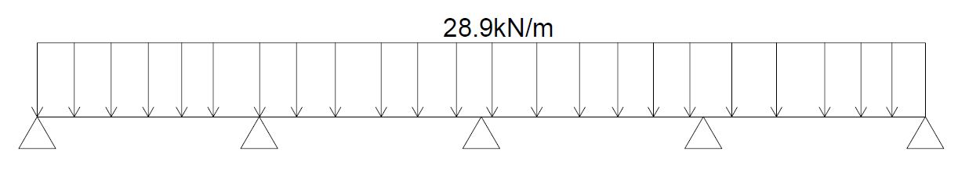W1= 8+2+18.9= 28.9 kN/m

Figure 5.1. Total external dead loads

External live loads:

Figure 5.2: Truck loads

Loads coming from trucks on both lanes of the road.

Here the total load of the truck w= 300kN is acting on the 20 m span, turning it into distributed load of,

W2= 300/20*2= 30 kN/m

The total loads coming from the external effects is then calculated as:

Wt= 28.9+30= 58.9 kN/m

Qt= 58.9*240 =14136 kN

According to these loads the cross sectional dimensions were estimated by engineering judgement and professional aid and dimensional values entered into the MIDAS software to carry out moment and stress analyses. The following cross-sectional dimansions at mis-span and support were obtained after careful iterative opertaions which computer program carried out. The values were again double checked for probable errors and settled upon as last dimensions.

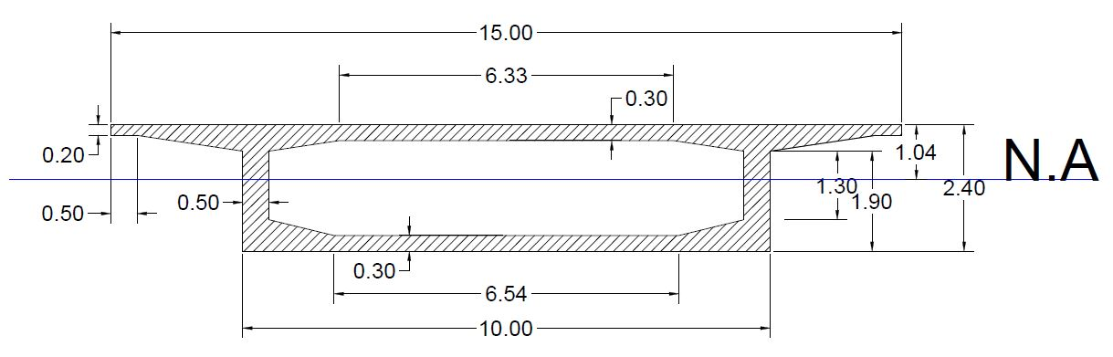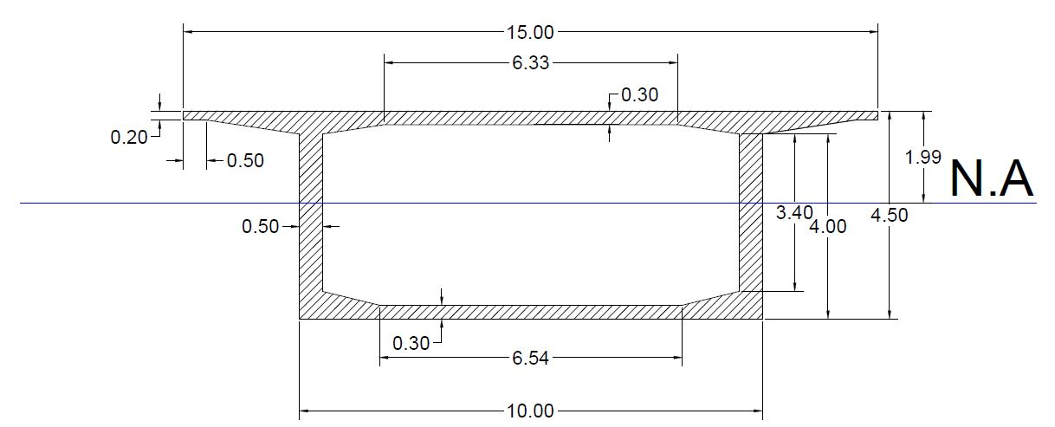

Figure 5.4 Cross section of the deck at mid-span

Figure 5.3 Cross section of the deck at pier support

The moment of inertia which is a function of the section sizes including the web and horizontal plate thicknesses are found as having a moment of inertia is I=39 m4 at support and I= 9 m4. Indeed, in the computer program based of the analysis of work 2 different values are going to be obtained; 1 at the mid-span and another one having larger value at the support value. The cross-sectional properties of the deck at support and mis-span regions are evaluated by computer program and tabulated as in table 5.1. Also, the moment of inertias at support and mid-span are calculated as follows,

Imid-span= 9 m4

Isupport= 39.76 m4

|  |  |  |  |  |  |  |  |  |
| --- | --- | --- | --- | --- | --- | --- | --- | --- |
|  | Shape | Name | Area m2 | Asy m2 | Asz m2 | Ix m4 | Iy m4 | Iz m4 |
| PSC | 1CEL | SUPPORT | 12.14 | 6.63 | 3.15 | 87.80 | 39.76 | 207.68 |
| PSC | 1CEL | SPAN | 10.04 | 6.78 | 1.17 | 24.61 | 9.03 | 160.26 |
| Tapered | 1CEL | ss | 12.14 | 6.63 | 3.15 | 87.80 | 39.76 | 207.68 |
| Tapered | 1CEL | ss2 | 10.04 | 6.78 | 1.17 | 24.61 | 9.03 | 160.26 |
| DB/User | SR | column | 3.14 | 2.83 | 2.83 | 1.57 | 0.79 | 0.79 |

|  |  |  |  |  |  |  |  |  |  |  |
| --- | --- | --- | --- | --- | --- | --- | --- | --- | --- | --- |
|  | Shape | Name | Cyp m | Cym m | Czp | Czm | Qyb m2 | Qzb m2 | Per.out (m) | Per.in (m) |
| PSC | 1CEL | SUPPORT | 7.50 | 7.50 | 1.99 | 2.51 | 10.29 | 38.14 | 38.44 | 24.90 |
| PSC | 1CEL | SPAN | 7.50 | 7.50 | 1.04 | 1.36 | 4.53 | 29.83 | 34.24 | 20.70 |
| Tapered | 1CEL | ss | 7.50 | 7.50 | 1.99 | 2.51 | 10.29 | 38.14 | 38.44 | 24.90 |
| Tapered | 1CEL | ss2 | 7.50 | 7.50 | 1.04 | 1.36 | 4.53 | 29.83 | 34.24 | 20.70 |
| DB/User | SR | column | 1.00 | 1.00 | 1.00 | 1.00 | 0.33 | 0.33 | 6.28 | 0.00 |

Table 5.1: values of stiffness obtained from MIDAS civil 2017.

Materials selected for the deck structure were as follows:

Concrete: C50 γc= 25kN/m3

Steel Reinforcement: S420 γs= 78.5 kN/m3

The neutral axis of the cross sections are as follows:

At support: 1.99 m from top slab

At mid-span: 1.04 m form top slab

Starting from the average geometrical size values structural properties are computed as

At support:

Area= 12.14 m2, H= 2.5 m

Load = 25*12.14= 303.5 kN/m

At mid-span:

Area= 10.04 m2, H= 4.5 m

Load = 10.04*25=251 kN/m

MIDAS gave us the total dead load of the deck structure as M= 64000 kN

∑dead=18.9+1+4=23.9 kN/m without load of the deck

Total dead load G=23.9*240 + 64000=69736 kN

For the live load calculations the truck loads that pass over the bridge is considered

Truck load = 30 tons= 300 kN

Distributed truck load, truck length considered 20 m

Loadtruck= 300/20 = 15 kN/m

Brake loads = 2.5 kN/m

∑live= 15+2.5= 17.5 kN/m

Qtotal= 5400+69736= 75136 kN

These loads were then inserted into MIDAS software for the analysis of the moments

The structural features are necessary and useful for evaluation and checking concrete stress values at the support and mid-span positions. It should be remembered that top fiber stress of a given section could be obtained by the relation σtop= M/I*u (upper level) In a similar way stress value created by the lower σbottom= M/I*v(lower level)

The remaining part of the design work is the evaluation of the longitudinal moment diagram of the deck system and the finding of moment values on the longitudinal direction

*Figure 4.2: The mechanism of post-tensioned technique - Creation of post-tensioning effect in structure elements and schematization of intra-sectional distribution of the critical points*

## 5.3 Longitudinal and Sectional Features of the Deck Structure

Figure 5.3.1 is showing the longitudinally the deck system. At the final stage of the project work the flexural moment diagram is to be obtained by means of computer programs. The cable is going to have parabolic computation having the largest eccentricity at the mid-span and eccentricity at the support. Cables are installed having a clear cover to the outer concrete crust approximately as 10 cm. But the construction technique is coming in this point to lead design process. As described in the Chapter2 figure. The structural system is going to be constructed in 4 parts. The moments caused by loads tracing roughly recalling the geometric diagram would reach ‘0’ at approximately 10 m from the support section. So because of this, first cabling operation would be realized that 70 m (60 m over the span and 10 m overpass) 

Step 4

Step 3

Step 2

Step 1

5.3.1

*Figure 5.3.1 longitudinal deck systems*

*Figure 5.3.2 Figure of the Construction Stage (Step 1-70m)*

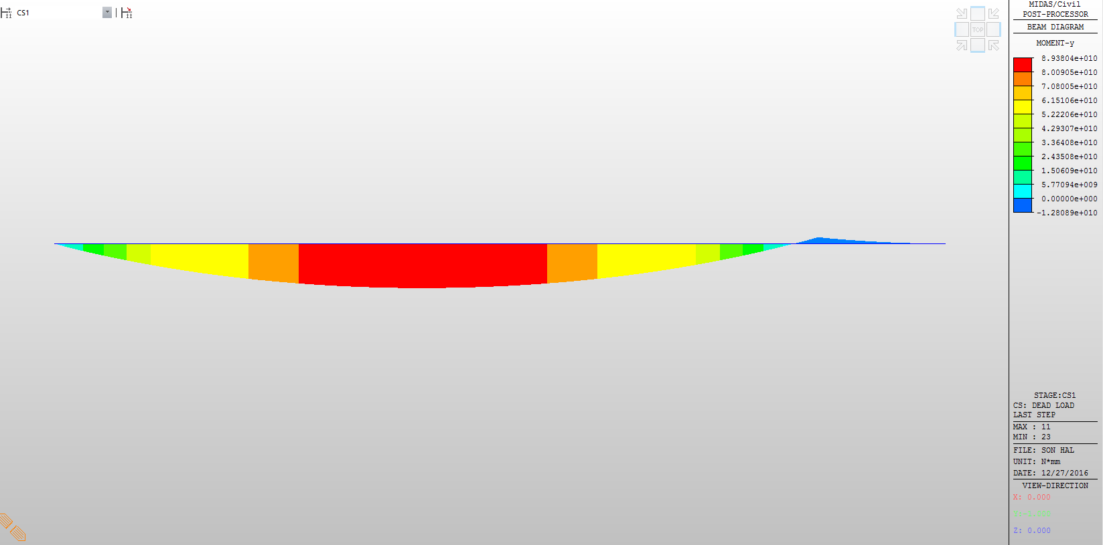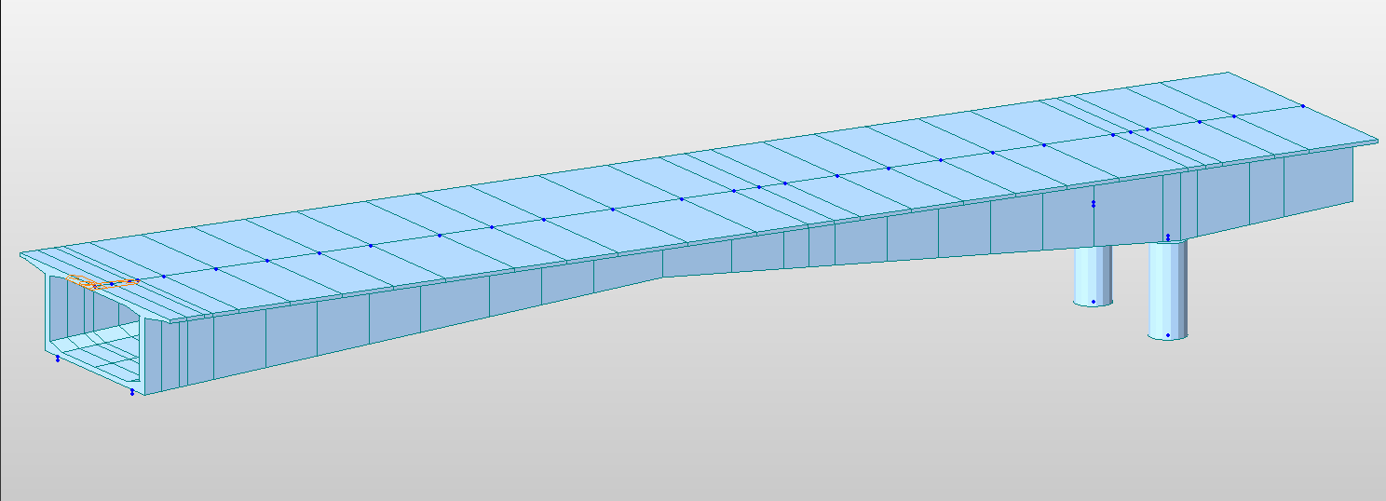As can be seen from the figure first 70 meter stage in construction, the structure acts as cantilever developing high stresses from the moments along the span of the structure. For this reason, the post-tensioning operation is carried out right after the hardening of the concrete in first stage. Thus, the high tensional stresses are eliminated.

*Figure 5.3.3 Moment Distribution Diagram of the Construction Stage (70m)*

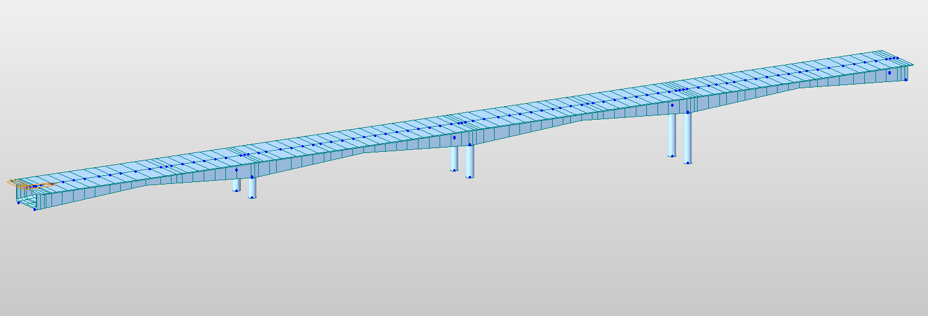

*Figure 5.3.4: Figure of the Final Construction Stage*

As can be seen from the above figure large moments occur in the first stage of construction due to cantilever behavior of the deck system.Moment acting in mid-span of the cantilever system:

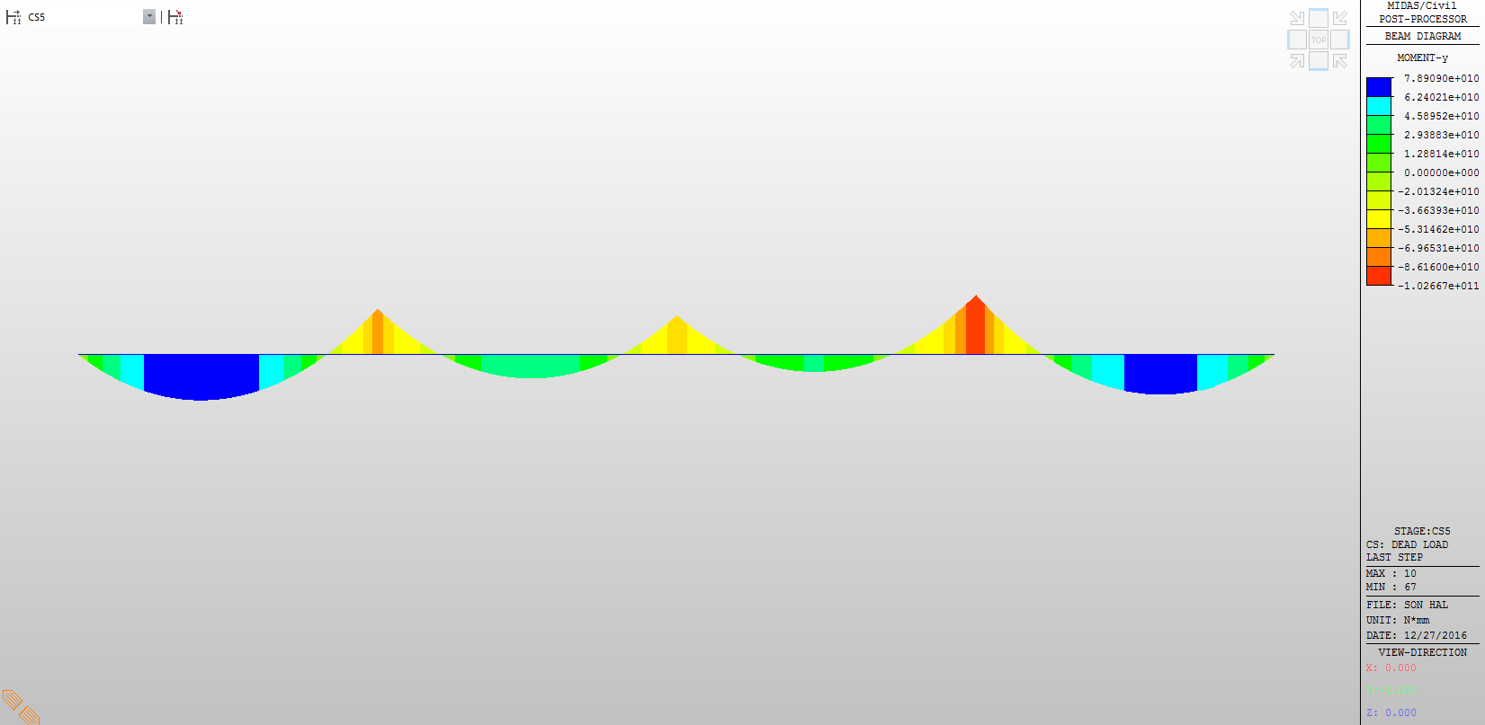M=8.94e+4 kN.m

*Figure 5.3.5: Moment Distribution Diagram of the Final Construction Stage (only dead load is considered)*

Figure 5.3.5 shows the distribution of the moments while only dead loads are considered, they being loads coming from asphalt, railings and structure deck itself.

Moments at midspan:

Moments at first and last spans:

Mm1=Mm2= 7.89e+4 kN.m

Moments acting on 2nd and 3rd spans:

Mm2=Mm3=4.59e+4 kN.m

Moments acting on supports:

Ms1= -8.62e+4 kN.m

Ms2= -6.96e+4 kN.m

Ms3= -1.03e+5 kN.m

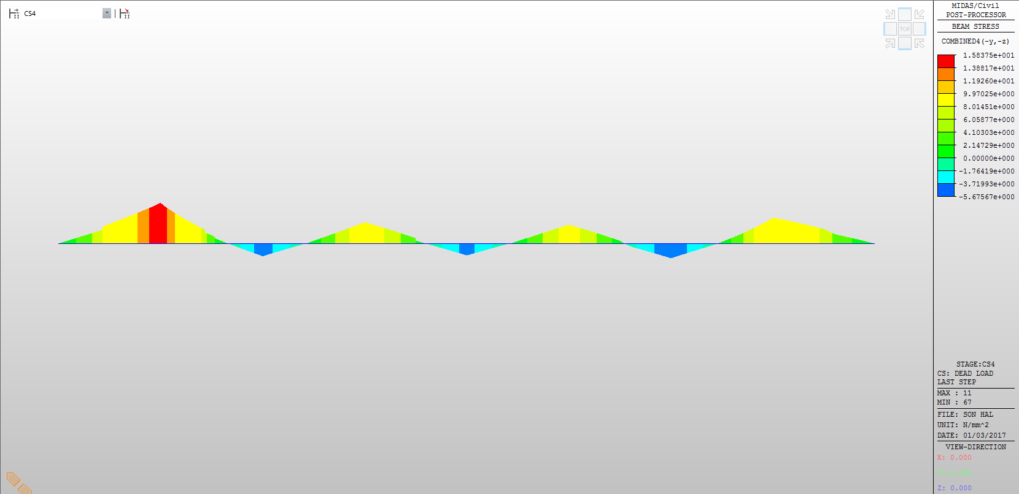The stresses created by these moments are as follows:

Figure 5.3.6: Stresses at bottom of the deck

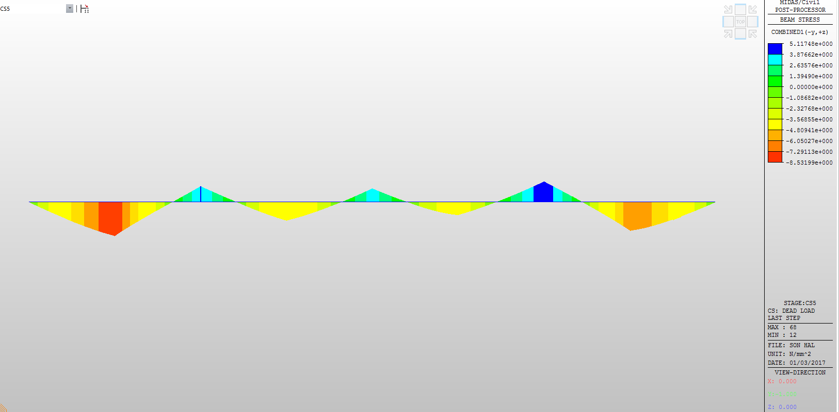

Figure 5.3.7: Stresses at top of the deck

The following table shows the stress values at critical points,

|  |  |  |
| --- | --- | --- |
| Name | Top section (kN/m2) | Bottom section (kN/m2) |
| Span 1 | -8.53e+3 | 1.58e+4 |
| Span 2 | -4.81e+3 | 9.97e+3 |
| Span 3 | -4.81e+3 | 9.97e+3 |
| Span 4 | -7.29e+3 | 9.97e+3 |
| Support 1 | 5.12e+3 | -5.67e+3 |
| Support 2 | 3.88e+3 | -5.67e+3 |
| Support 3 | 5.12e+3 | -5.67e+3 |

Table 5.2: Stress values

As can be seen from the table above stresses are negative in compression and positive in tension. Stresses are compression in top of midspan and bottom of the support sections. Tension in bottom of the span and top of the support sections.

The post tensioning cables are installed staring from the top of the first abutment side deck and continue going up and down along the cross section having connection were the moment is zero, with other cables. To create compression forces where the loads create tension due to moments, tendons will be installed where there is compression. Since we use compler connections at the joints or connections no need for additional binding concrete material. However, additional concrete mass was used in diaphrams to create more stiffness at support level.

The junction details are going to be provided at the final report. Here it should be briefly summarized that the junctions used to be achieved by the dead anchorage block installed in the mass of concrete continuing them. These dead anchors would be pressed in such a way that parts of going in one direction and other directions would be installed in neighboring position in the concrete mass in our days new devices have been developed allowing constructing junctions between neighboring cables without overlapping in the junction. Two edges coming from two parts of the deck and joining moments equals 0 sections longitudinally are linked one to other mechanically. The junction was obtained by mass concrete binding to connect two coming cable masses in the Zuregvan bridge construction it being older and approved method.

## 5.4 Flexural moments affecting the deck and cable post-tensioning installation

The flexural moments acting on the deck create tension in the bottom part of the mid-span and tension on the top part of the support sections. Thus a concrete mass was added to the support parts void and additional flexural stiffness created while the mid-span cross-section stayed more light and less in height. Our concern is to make bridge strong and durable along while creating less dead loads that make structure heavier to eliminate unnecessary stresses and save from material, and more pleasing to the eye.

**6. Installation of Post-Tensioning Cables**

**6.1 General Overview of Post-Tension Cabling**

As mentioned in chapter 5 post-tensioning is needed to overcome the long spans in bridges and other structures like slabs.



Figure 6.1 Post-tensioning cable properties

The cables that were used were 19c15 cables, 32 at each midspan and support.

Total number of cables is N=32*3+32*3=192 pieces

Length of the cables…

stresses due to dead+live loads moments:

u: eccentricity from top slab

v: eccentricity from bottom slab

Mid-span tension stresses:

σt= Mm*v/Im

Support tension stresses:

σt =Ms*u/Is

After the post-tensioning operation this stresses become:

At mid-span:

σt=

At support:

σt=

All these obtained stresses should be greater than zero as it is the main goal of post-tensioning operation, to eliminate tension forces in the deck.

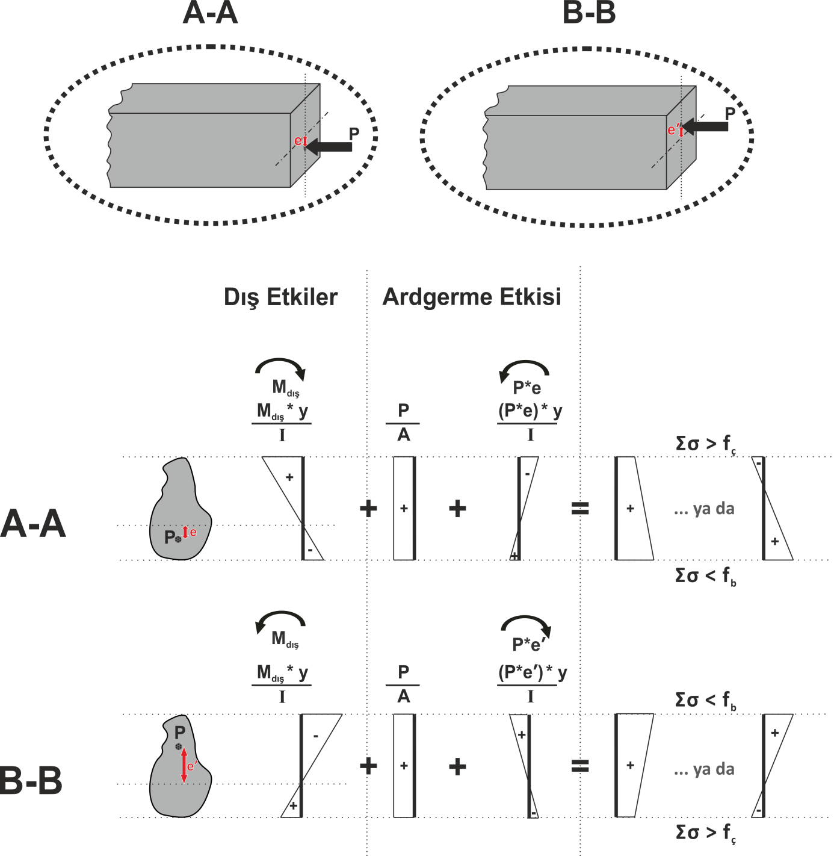

**6.2 Cabling details along the deck component**

A detailed computer based analysis of the deck would be provided as previously explained, in the final report. MIDAS software provided us with detailed load analysis of the deck structure, that is, as shown previously moments created by loads and their action on the structure.

In Figure 6.2 the boxes are anchorage plates of the tendons. In our design, we have tried to catch a clear cover that it would not be disturb the tendons itself and concrete also. In mid-span, as it is mentioned previously there are 12x12C15 tendons.

Figure6. 3 Cabling detail throughout the 240 m span

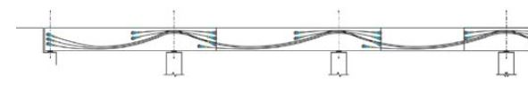In cross-section of supports cross-sections are changing a little bit. From our calculations, it is advised to use 3x12C15 in order to reach designated force component. For that particular reason, mid-span tendons are transitioning from bottom web to the top slab concrete. Also, additional 3x12C15 is provided at the supports to help reinforcing greater moments than those of mid-span. Cross-section of support post-tension reinforcements can be found in Figure 6.3. Indeed, this transition has certain geometry. However, these calculations and geometry will be provided in computer based software. Therefore, these exact calculations will be given in the final report. On the other hand, an approximation of this transition can be found in Figure 6.4.

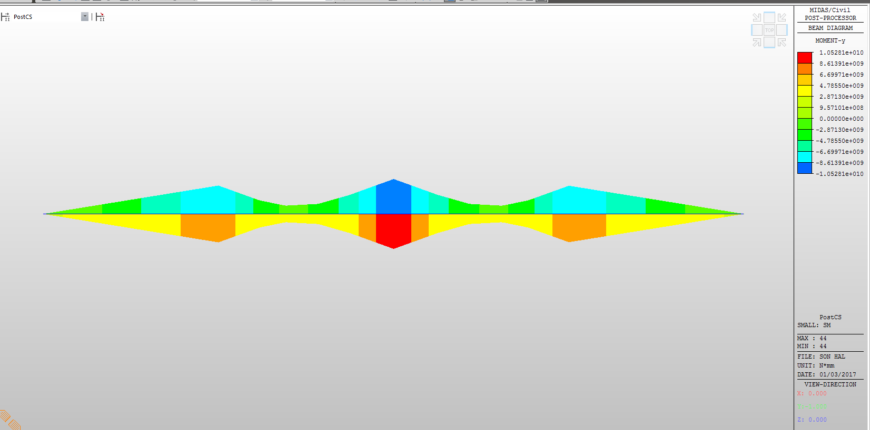

Figure 6.4: Moment Distribution Diagram of the Final Construction Stage

Stresses that follow this moments are shown below. There it can be seen that all the stresses are compression both under and above the NA.

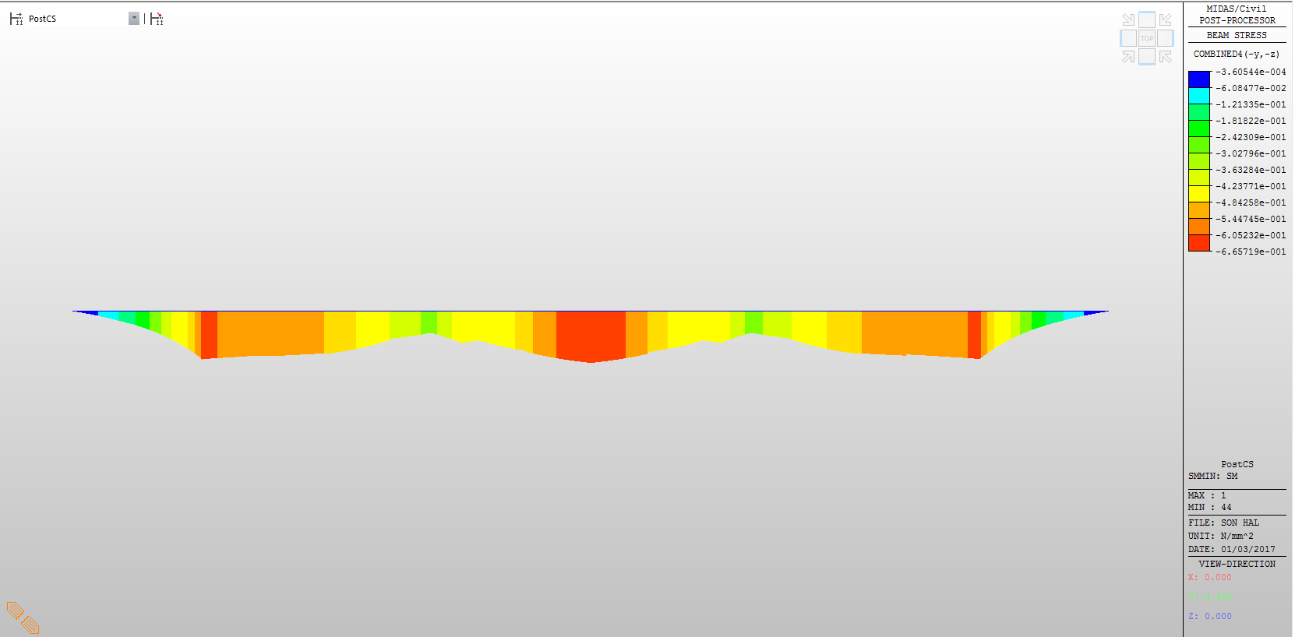

Figure 6.4: Stresses at bottom of the deck after post-tensioning

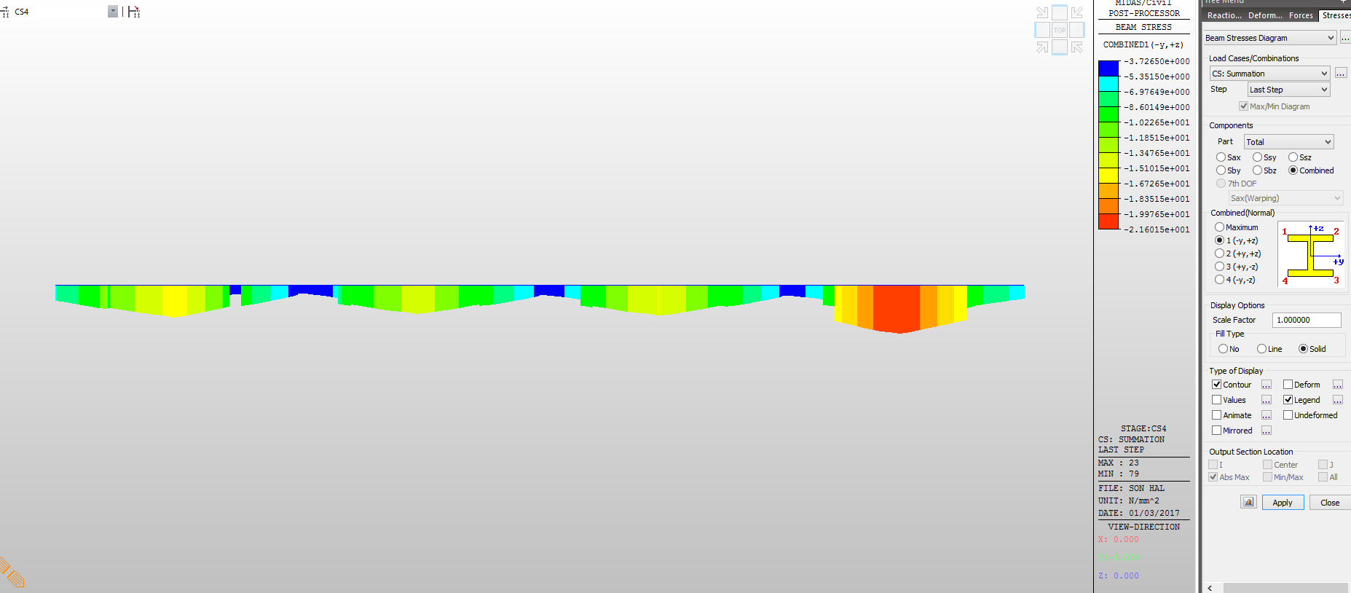

Figure 6.5: Stresses at top of the deck after post-tensioning

Table were all the loads are shown is below

|  |  |  |
| --- | --- | --- |
| Name | Top section (kN/m2) | Bottom section (kN/m2) |
| Span 1 | -1.67e+4 | -6.05e+4 |
| Span 2 | -1.51e+4 | -4.84e+4 |
| Span 3 | -1.67e+4 | -4.84e+4 |
| Span 4 | -2.16e+4 | -6.05e+4 |
| Support 1 | -3.72e+3 | -5.44e+4 |
| Support 2 | -3.72e+3 | -6.05e+4 |
| Support 3 | -3.72e+3 | -5.44e+3 |

Table 6.1 : Stresses

Materials used and load calculations:

* **At mid-span:**

**σt=+ -**

* **At support:**

**σt= + -**

* 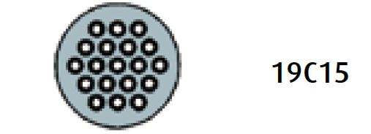**Cable material used: 19C15 cables**

Figure 6.6 Deatil of tendon

**fs= 1860 Mpa**

**Ф= 15mm**

**#= 19**

The finalized cabling deatil of the bridge,

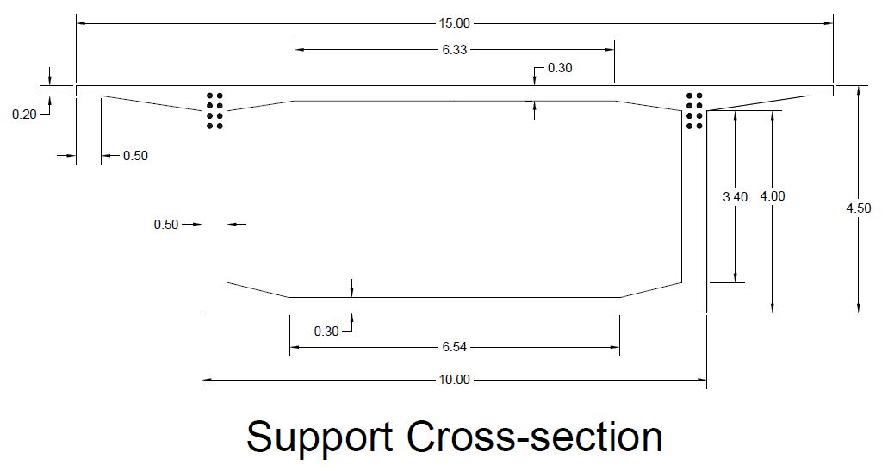

Figure 6.7 Cable details at support

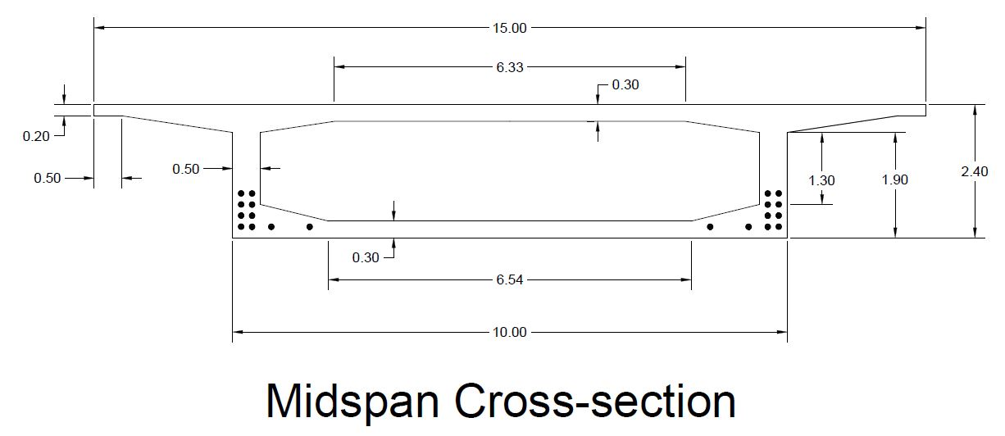

Figure 6.8 Cable details at midspan

From the figure of cable detailzation at midspan it can be seen that we have additional cables at bottom. This part is reffered to as blisters and made when cross section is not enough to hold cables at bottom.

In total we have 16*4+4*4=80 cables each approximately 60 m long

**6.3 Transversal cabling**

Transversal loads acting on the deck is another issue to be considered when designing post-tensioned bridges. Since the width of the deck is relatively large

w= 15m

and the two side road is present on it there is always a place for uneven distributed loads along the deck. High vertical loads acting on the deck will create moments similar to longitudinal moments in the transversal direction also. So it would be good approximation to install 12C15 cables along the deck with spacing of s=20 cm.

# 6. Design and construction of piers

**6.1 Construction of piers**

As mentioned in the chapter 2, 3 piers of the bridge are constructed by application of different methods. For two of them land surface being naturally dried during summer times as sufficiently large construction area was formed. Footings and pier masses in concrete for these two piers well-constructed rather easily. No special precautions concerning their erection were needed. As for the 3rd pier area behind the pier floating was lying in all seasons in the water. An artificial island has been constituted in order to create a dry surface to advance the construction of footing and the piers. On the other hand, it should be added that two separate circular columns each having a diameter of 2 m and distanced 6.5 meters would be sufficient for the vertical bearing system (Figure 5.8). Over the span, length of the columns is varying due to geological conditions. First column’s length is 5 meter, second column’s length is 8 meter and last column’s length is 12.5 meter. An approximation of the bearing system can be found below in Figure 5.8 and Figure 5.9.

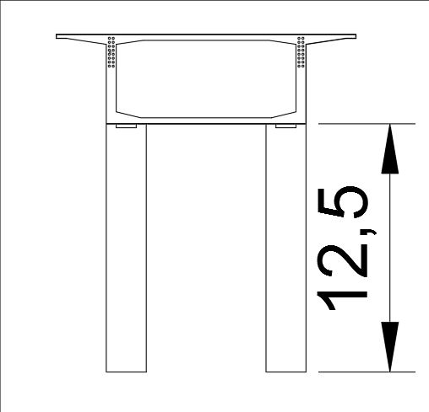

Figure 5.8

Figure 5.9

Figure 5.9 Bearing system

## 6.2 Earthquake

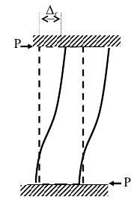At the case of earthquake, the columns are charged by horizontal loading effect. Columns are no inflected at the mid-height of their height because of the elastically moving supports braces at the head of each column. System would behave as a continuous beam simply supported at the head of each column. On the other hand, longitudinal effect of the deck under earthquake action would create geometry of deformation as approximated in Figure 5.10.

**Figure 5.10**

For determining loads on columns due to earthquake forces, AASHTO LRFD Bridge Design Manual is taken into consideration and “Deprem Bölgelerinde Yapılacak Binalar Hakkında “Esaslar” manual is taken into consideration for eliminating probable mistakes. According to to code some properties should be defined. Ao is taken according to earthquake zone. Zuregvan bridge area is equivalent to earhquake zone 2 therefore, A0=0.3. After that, building importance factor is another constant that should be defined for earthquake design.

This value is taken as 1.5 due to importance of a bridge. A bridge cannot be unusable after an earthquake. After that spectrum coefficients should be estimated for an earthquake. Following table (Table 5.1) is shows the spectrum of Zuregvan Bridge location. To start analyzing, some of the properties must be calculating.

For the earthquake load of our structure some of the properties which are related with our structure should be given here. These properties contains; Response Spectrum, Period of Bridge (short and long), Earthquake region, Classification of Soil, Total Weight of Superstructure, Total Weight of Column, Total Weight Taken Into Consideration.

|  |  |  |
| --- | --- | --- |
| **TABLE: Function - Response Spectrum - User** | | |
| **Name** | **Period** | **Accel** |
| Text | Sec | m/s2 |
| S2_A03 | 0 | 0,75 |
| S2_A03 | 0,4372 | 0,75 |
| S2_A03 | 0,6 | 0,6073 |
| S2_A03 | 0,8 | 0,5013 |
| S2_A03 | 1 | 0,432 |
| S2_A03 | 1,2 | 0,3826 |
| S2_A03 | 1,4 | 0,3452 |
| S2_A03 | 1,6 | 0,3158 |
| S2_A03 | 1,8 | 0,2919 |
| S2_A03 | 2 | 0,2721 |
| S2_A03 | 2,5 | 0,2345 |
| S2_A03 | 3 | 0,2077 |
| S2_A03 | 3,5 | 0,1874 |
| S2_A03 | 4 | 0,1714 |
| S2_A03 | 4,5 | 0,1454 |
| S2_A03 | 5 | 0,1263 |
| S2_A03 | 5,5 | 0,1112 |
| S2_A03 | 6 | 0,0991 |
| S2_A03 | 6,5 | 0,089 |
| S2_A03 | 7 | 0,0807 |
| S2_A03 | 7,5 | 0,0736 |
| S2_A03 | 8 | 0,0675 |
| S2_A03 | 8,5 | 0,0623 |
| S2_A03 | 9 | 0,0577 |
| S2_A03 | 9,5 | 0,0537 |
| S2_A03 | 10 | 0,0501 |

Period of bridge= T = 2.56 (short)

T=2.61 (long) shorter value is taken into consideration.

Second degree earthquake region = A0=0.3

Classification of soil= S2

Total weight of superstructure = 64000 kN

Total weight of columns = 4006 kN

Total weight taken into consideration = 70000 kN

For load combination 1G + 1Q + 1E is taken into consideration. Where G = dead load, Q = live load E = earthquake. Wind load did not taken into consideration because there were not any wind and earthquake combination together. In this analysis critical one is selected which is came to be earthquake force.

For vibration period as it is mentioned Tx=2.56s and Ty=2.61s is defined from the program Midas Civil 2017.

Also there are some seismic isolators in top of every column. Coefficients of these isolators can be found below;

-Horizontal stiffness: 7530 N/mm

-Vertical stiffness: 10^12 N/mm

-Damping coefficient: 1.5

-Absorb ratio: 20%

For the soil parameter following table is taken from AASTO LRFD Bridge Design Manual. For soil type 2 soil profile coefficient is came to be 1.2.

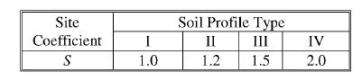

Table 5.11

After that elastic seismic response coefficient is calculated with the below equation.

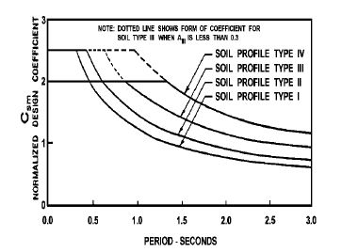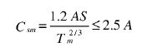With this formula elastic seismic response coefficient can be calculated. $C_{sm}=\frac{1.2*0.3*1.2}{{2.56}^{2/3}}=0.022<0.75$,where Tm used as the low value since it is more critical than the larger value. However, since our natural periods do not change much it does not make a great difference.

Table 5.12 show the variation of Csm and period values according to soil profiles.

Table 5.12

Table 5.13 importance category of the bridge can be estimated. In our situation, the bridge is accepted as essential bridge which is having a higher importance factor than critical bridge.

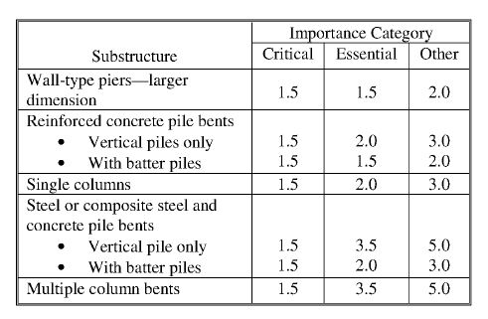

Table 5.13

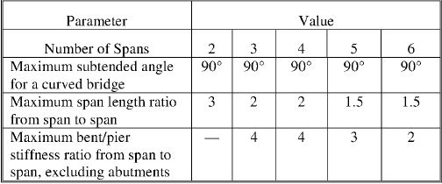For the analysis on earthquake related issues Table 5.14 must be satisfied. In this table for the curved or linear bridges, there are some ratios which should be satisfied and also selected essential bridge we can see that our bridge has to be analyzed with Single Mode Analysis and Uniform Load Method. However, in this student project, we analyzed this bridge according to Uniform Load Method.

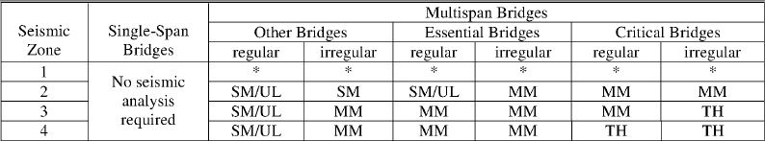

Table 5.14

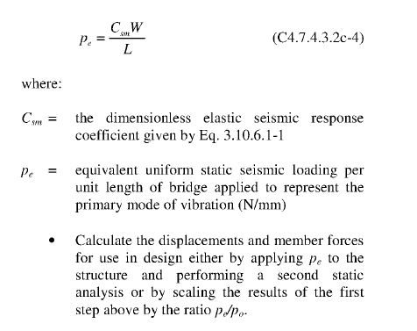

With AASHTO LRFD Bridge Design Manual’s C4.7.4.3.2c-4 equation load which acting uniformly on the bridge is calculated as 6.42 kN/mm2

With this uniform load the horizontal force which is acting on columns due to earthquake can be calculated as;

-Fx=Fy=80.25 kN (at 12.5 meter column)

- Fx=Fy=51.36 kN (at 8 meter column)

- Fx=Fy=32.1 kN (at 5 meter column)

With these loads, since 12.5 meter column is the most critical column, it can be calculated that;

* Maximum moment due to horizontal force = 501.56 kN.m
* Maximum shear force developed at the column = 80.25 kN
* Axial force acted on the one single column = 7000 kN

**6.3 Column Design Considering Earthquake and Loads**

Used materials in the columns are stated below;

-C50 concrete

-S420 for reinforcing steel

To be able to design column procedure in TS500 must be followed. To starting the procedure deflection at the bridge level must be calculated. For the deflections, every column is modeled as a cantilever beam which a uniform force acting this beam that force is representing earthquake force of every single column. For the design of columns, obviously most critical columns are the 12.5 meter long column due to probability of slenderness and greater moment applied to this column. 12.5 meter column is modeled and deflections of each element are calculated as stated in Figure 5.11.

Figure 5.11

$$∆=\frac{6.42*{12.5}^{4}}{8*28000*{10}^{3}*π*\frac{2^{4}}{64}}+\frac{6.42*8^{4}}{8*28000*{10}^{3}*π*\frac{2^{4}}{64}}+\frac{6.42*5^{4}}{8*28000*{10}^{3}*π*\frac{2^{4}}{64}}=1.06 mm$$

After deflection check from structural analysis it can be found that;

-Nd=9800 kN

-Vd=80.25 kN

-Md=501.56 kN.m

For both x and y direction sidesway check are same.

For the sway check, $φ=1.5*1.06*\frac{\left(\frac{9800}{12500}+\frac{9800}{8000}+\frac{9800}{5000}\right)*2}{\left(80.25*2+32.1*2+51.36*2\right)}=0.0385<0.05$, so it is a side-sway prevented frame.

For x plane,

$α_{1}=0, α_{2}=\frac{\frac{\frac{π*2^{4}}{64}}{12500}}{\frac{56.2}{60000}*2}=0.034$

$α_{m}=0.017$

k=0.7

lk=8750 mm

$\frac{l_{k}}{i}=\frac{8750}{0.25*2000}=17.5<34$, so it is a short column.

$e_{min}=15+0.03*h=75, e=\frac{501.56}{9800}=51.18$, so take Md=735 kN.m

$\frac{N_{d}}{b*h*f_{cd}}=0.09, \frac{M_{d}}{b*h^{2}*f_{cd}}=0.0035, so use ρ_{min}=0.01=> A_{s}=31416 {mm}^{2}$

So, using $60φ26 steel.$

For y plane;

$α_{1}=0, α_{2}=\frac{\frac{\frac{π*2^{4}}{64}}{12500}}{\frac{24.4}{60000}*2}=0.08$

$α_{m}=0.04$

k=0.704

$\frac{l_{k}}{i}=\frac{0.704*12500}{0.25*2000}=17.6<34$, so it is short column too. Area of steel will be the same.

After reinforcement in axial direction, shear force should be taken into consideration for reinforcements.

Shear Design;

Vd=80.25 kN

$V_{cr}=0.65*2*\frac{π*{2000}^{2}}{4}*1.22=4982566 N=4983 kN$

Where, $γ=1+0.07*3.12=1.22$

Vmax= 22808 kN

Vd<Vcr use minimum web reinforcement.

$\min{\frac{A_{sw}}{s}=0.3*\frac{2}{365}*2000=3.29, use 12 mm bars, s=70 mm, to support s=35 mm.}$

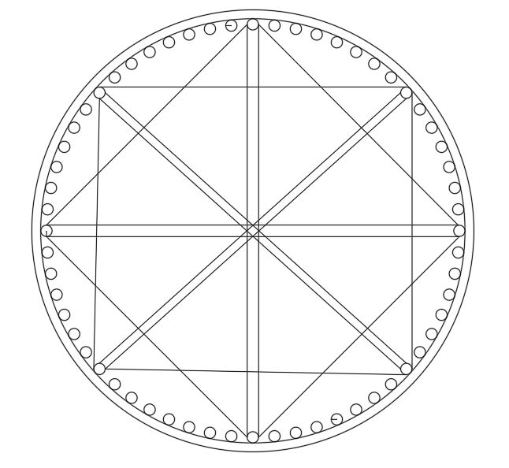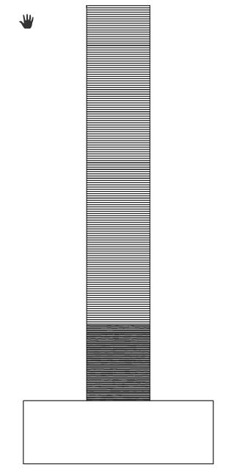Typical dimensions of the columns can be found in Figure 5.12.

$$60φ26$$

S=70 mm at top s=35 mm at bottom

# 7. Geotechnical Design

**7.1 Load Combinations**

In order to design the foundation system for the bridge, all types of forces that are transmitted to the soil have to be determined. The basic idea in order to determine the design loads for the foundation is to specify the most critical load combination, so that it ends up with the design of the largest piles and rafts or completion of safer ground improvement techniques. When the most critical loading case is determined, by designing a foundation system for that combination, safety is also satisfied for other cases.

Different load groups are used in order to find the most critical load combination. The post-tensioned highway bridge is a heavy structure, and this characteristic of it ends up with a high earthquake load. On the other hand, the bridge is in 1st earthquake zone. After calculating different load combinations, the most critical one is found to be:

Load Combination = (1.0) * D + (1.0) * L + (1.0) * E where;

D: Dead Load

L: Live Load

E: Earthquake Load

**7.2 Foundation System**

As a trial foundation system, a square single footing for each pier is considered. All calculations for a single footing are carried out. The widths B and L are estimated from the dimensions of the piers. Piers are selected to be in columns. The diameter of single column is estimated as 2m. Columns are constructed perpendicular to traffic flow as shown in the figure 8.1.

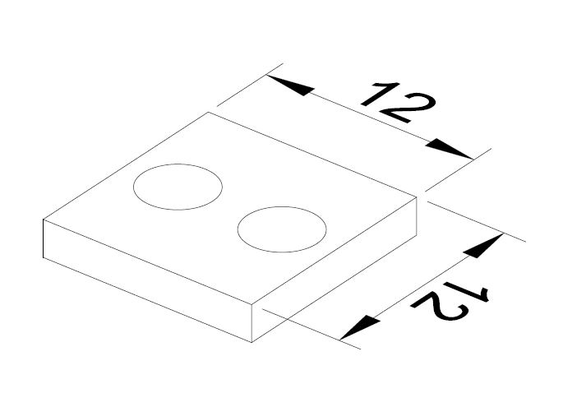

*Figure 8.1 Initial Foundation Design*

**7.3 Calculating Total and Net Foundation Pressures**

In order to determine Total Load = ΣQ, the weight of the footing has to be added to the structural loads that were determined before and it is calculated as 1280 tons.

Concrete unit weight has been taken as 2,5 t/m3,

Weight of the raft = 12 * 12 * 2 * 2.5 = 720 tons

The pier load calculations:

Total weight added to the load and axial design load that come from structural analysis is 1280 tons

Total weight that is transmitted to the soil = 1280+720= 2000 tons

**7.4 Soil Profile**

The idealized soil profile is created by considering the tests carried out. Between 0-8.00m depth, alluvium layer exists. The alluvium layer is assumed to be clayey gravel and from the reference table given in the appendices f=30° and g=19kN/m3 is used for this layer. Beneath this layer between 8.00-20.0m depth, there exists weathered claystone-serpentine alternation. This layer is assumed to behave like Intermediate Geomaterial layer and: Assuming Claystone-Serpentine alternation is an Intermediate geomaterial, a cohesion value of Cu=400kPa is selected

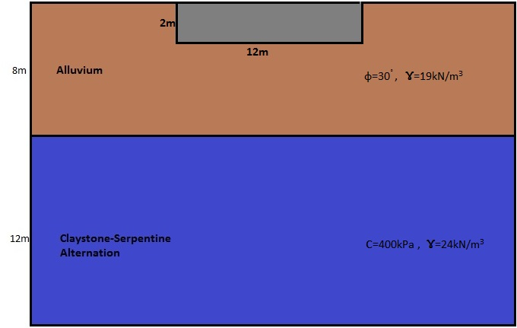

*Figure 8.2 Soil Profile*

**7.5 Net Foundation Pressure**

The weight of excavated soil = 12*12*2*19=5472 kN

qnet = (Total weight – excavated soil) / (B*L) = (20000-5472) / (12 * 12)

qnet = 101 kPa

**7.6 Settlements**

**7.6.1 Immediate Settlement**

Si = μ0 * μ1 * q * B / E

Where

μ0 and μ1 are the empirical factors dependent on the foundation geometry.

q, the net foundation pressure = 101 kPa

B, the lesser dimension of the raft = 12 m

E is the modulus of elasticity = 800 kPa

μ0 and μ1 are determined by using Fig ?

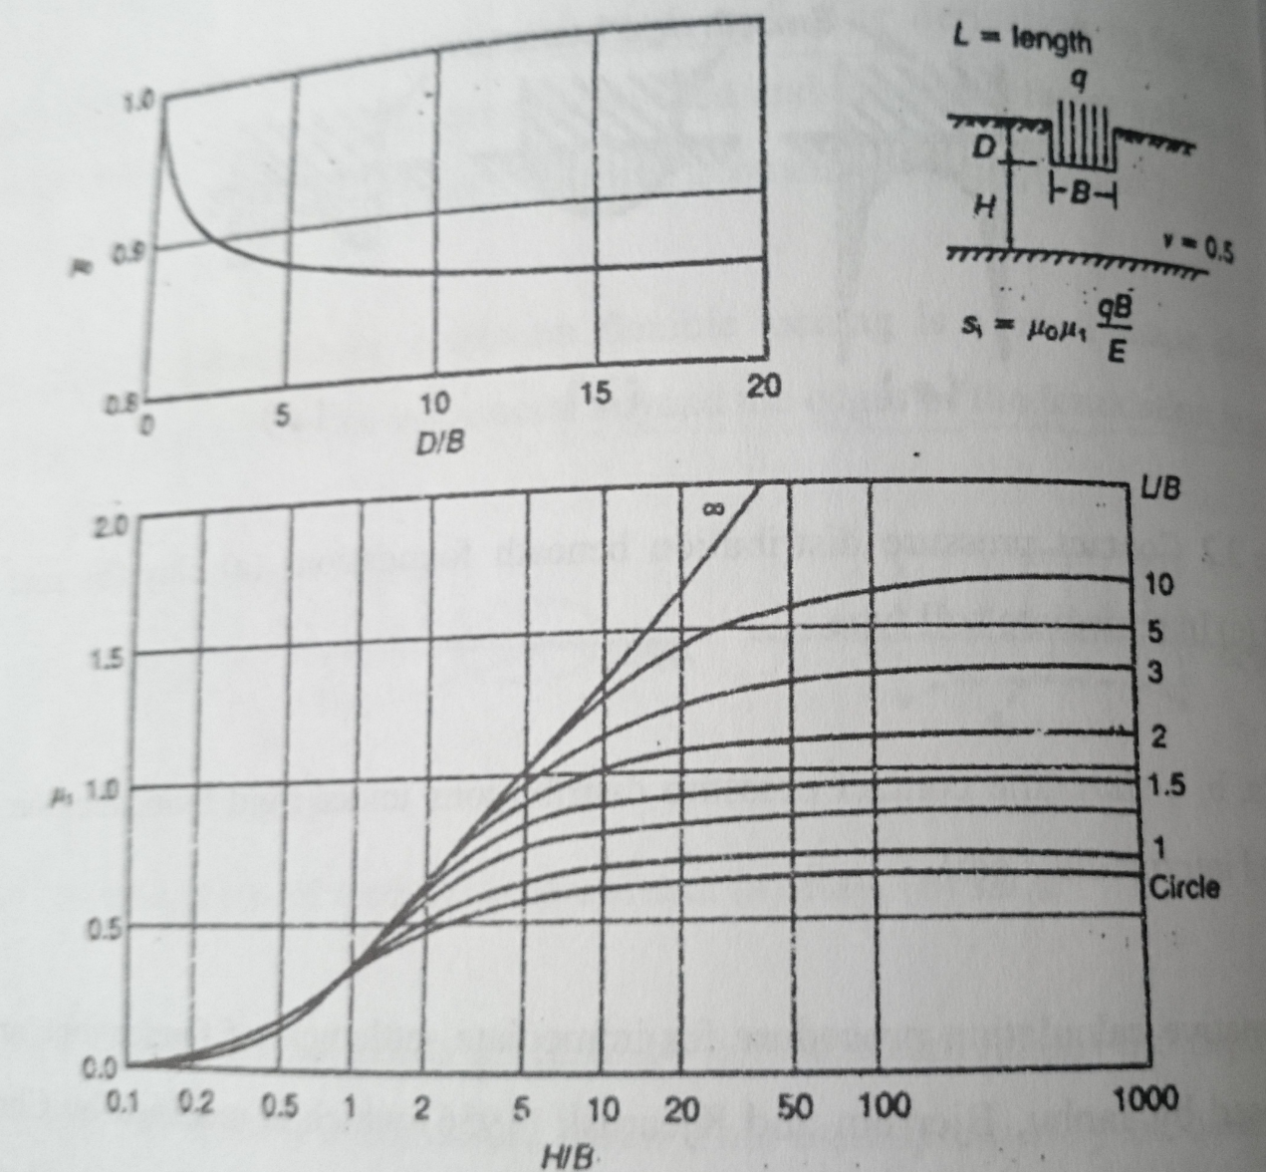

*Figure 7.3 Coefficients for Immediate Settlement*

We assume compressible height is 10 m.

D/B = 2/12 = 0.17

μ0 = 1.0

H/B = 10/12 = 0.83

L/B = 12/12 = 1

μ1 = 0.25

S = 1.0 * 0.25 * 101 * 12 / 800 = 0.379 m = 38 cm

38 cm settlement is high, so we need to support the system with piles.

**7.7 Ultimate Capacity**

For the sand layer:

qf = (1 / 2) * sγ * γ * B * Nγ + sc * c * Nc + sq * γ * D *Nq

for sand layer, c = 0

D = 2 m

Shape factors for vertical loading on rectangular footing:

sq = 1

sγ = 1 - 0,2 * (B / L) = 0,8

sc = 1+0,2*(B/L) = 1,2

Hatanaka and Uchida (1996);

Φ= 30

Nγ = 19 from the Terzaghi’s dimensionless bearing capacity factors vs Φ chart.

Nq = 19 from the Terzaghi’s dimensionless bearing capacity factors vs Φ chart.

Nc = 30 from the Terzaghi’s dimensionless bearing capacity factors vs Φ chart.

qf = ( 1 / 2 ) * 0,8 * 19 * 12 * 19 + 1 * (19) *2*19= 2455 kPa

2455 / (101) = 24 > 3,0

**7.8 Pile Design**

Bored Piles are found to be the best solution for this structure because of economic reasons when compared other piling methods. There are two factors that affect the design of bore piles, one of them is Skin Friction and the other is end bearing capacity. These two and their contribution to the total strength of the pile will be discussed further below.

According to the soil profile, between 0-8.00 m depth Alluvium layer exists. The alluvium layer is assumed to be clayey gravel and from the reference table given in the appendices Φ =30° and g=19 kN/m3 is used for this layer. Beneath this layer between 8.00-20.0 m depth, there exists weathered claystone-serpentine alternation. This layer is assumed to behave like Intermediate Geomaterial layer and: Assuming Claystone-Serpentine alternation is an Intermediate geomaterial, a cohesion value of Cu=400 kPa is selected.

**7.8.1 Skin Friction**

For 8 m alluvium layer,

$$f_{si}=K_{si}*\tan{δ_{i}*σ_{si}}$$

Where;

*Ksi*: Coefficient of Lateral Pressure, for sands in bored pile: 0.5

$δ_{si }:$ Wall Friction for granular soil layer

$σ_{vi}:$ Vertical effective stress at the middle of soil layer

For 0-8.0m Alluvium layer (Internal Friction angle, Φ=30°)

(2/3)*30o = 20o

We assume water table is at the surface.

$σ_{vg}:$ (19-9.81)*8/2 = 36.7 kPa

$$f_{sg}=0.5* \tan{20*36.7=6.7 kPa}$$

Qsg = 3.14*6.7*8 = 168 kN = 17 tons

For 8.0-20.0m claystone-serpentine alternation layer (Cohesion, cu=400 kPa)

Qf = 3.14*0.21*400*12 = 3165 kN = 317 tons

Cumulative Skin Friction, Qs = 17+317 = 334 tons

**7.8.2 End Bearing**

The end bearing of a pile foundation structure could be found by;

A = 3.14 * 12 / 4 = 0.785 m2

For bearing capacity factor, at NAVFAC DM 7.2 Nc=9 is offered

For static conditions, factor of safety for side friction F.S.= 2 and for end bearing F.S.=3 is used.

Allowable pile capacity is calculated as:

Qall=(282.6/3)+(334/2) = 261.2 tons = 2612 kN

Number of piles $n= \frac{20000}{2612}=8$

Each pile diameter is estimated as 1 m.

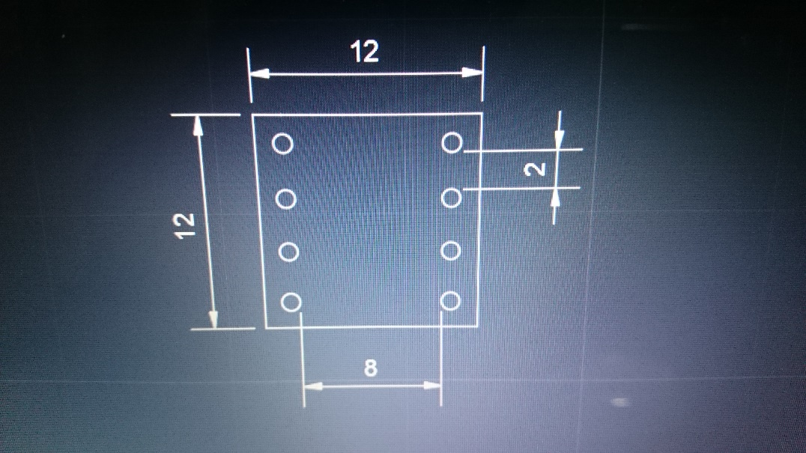

*Figure 7.3 Pile Placement*

**7.9 Pile Group Capacity**

Qag = N * Qall * number of piles

Qag is allowable group capacity.

N, efficiency = 1 - arctan(D/s) * [ (m-1) * n + (n-1) * m ] / ( 90 * m * n )

m = 4 and n = 2

N = 0.63

Qag = 13164 kN

**7.10 Lateral Force Capacity of the Pile Group**

Lateral load for 1 group is 80.25 kN.

The highest column height is 12.5 m. Others are 5 and 8 m.

Highest moment is M = 1003 kN.m

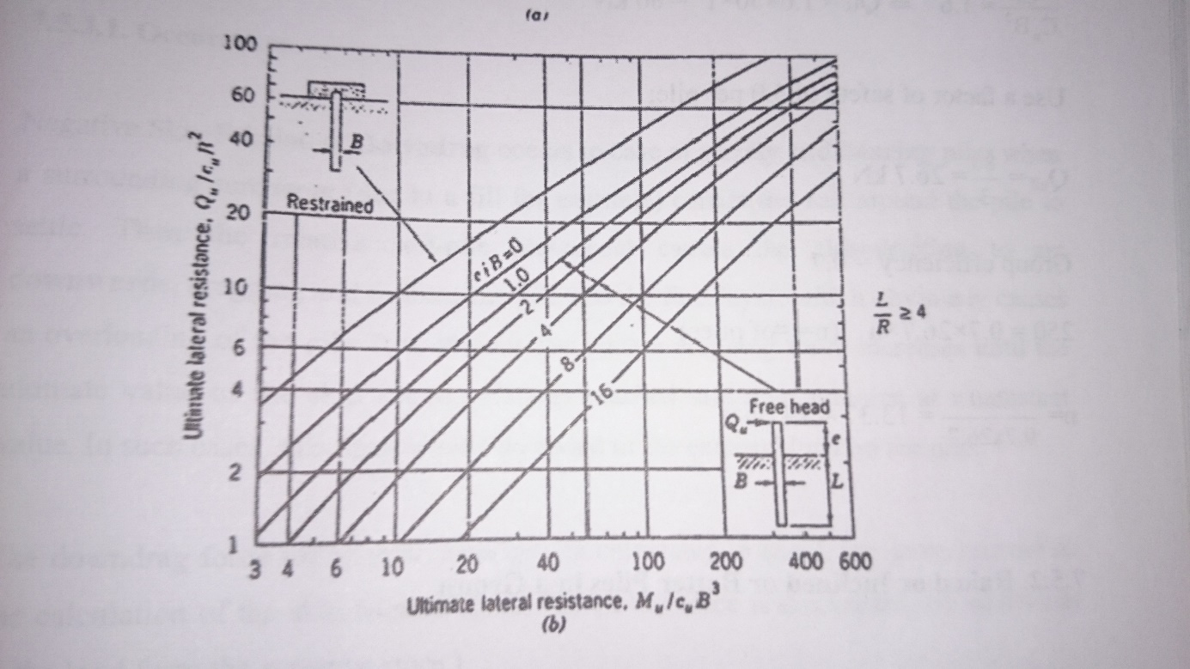

*Figure 7.4 Ultimate Lateral Resistance of a long pile in cohesive soil*

We assume cu is 200 kpa.

M/cuB3 = 5

From above figure, Qu/cuB2 = 5.5

Qu = 1100 kN

Factor of safety per pile is 3.0.

Qall = 1100/3 = 367 kN

Group efficiency = 0.63

Lateral force capacity of the group = 0.63*367*8 = 1850 kN

1850 kN > 80.25 kN so our system is safe.

# 8. Aspects of Cost Estimation

The studied bridge with the typical example of the continuous post tensioned deck bridges starting from engineering experience the cost of such bridge structures including their reinforced concrete piers is approximately known. Also it would be able to calculate approximate cost of the bridge. Our studied bridge for the full structure would arrive to 56000 TL/m. It comes to 13.5 million TL. But the real cost considering the Iraqi conditions this project cost 25 million TL.

In order to estimate precise price, several things is considered. Firstly materials that will be used in the project are determined. These are excavation, concrete works, rebar, foundation pile driving, formwork, tendons, earthmoving, and scaffolding

We started with a quantity take-off of concrete works for foundation, piers and the deck.

There are three pier columns each has different height

|  |  |  |  |  |  |  |  |  |  |  |
| --- | --- | --- | --- | --- | --- | --- | --- | --- | --- | --- |
| **Concrete Footings (C35)** | | | | | | | |  |  | |
| *width(m)* | *length(m)* | | *height(m)* | | *Quantity* | | | *Volume(m3)* | Total volume(m3) | |
| 12 | 12 | | 2 | | 3 | | | 864 | 864 | |
| **Concrete Piers (C50)** | | | | |  | | |  |  | |
| *radius(m)* | *height(m)* | | | | *Quantity* | | | *Volume(m3)* |  | |
| 1 | 5 | | | | 2 | | | 31,4 |  | |
| 1 | 8 | | | | 2 | | | 50,24 | Total volume(m3) | |
| 1 | 12,5 | | | | 2 | | | 78,5 | 160,14 | |
| **Concrete Deck (C50)** | | | | | | | |  |  | |
| *cross section area at support (m2)* | *cross section area at midspan (m2)* | | *average area (m2)* | | *length(m)* | | | *Volume(m3)* | Total volume(m3) | |
| 12,14 | 10,04 | | 11,09 | | 240,00 | | | 2661.06 | 2661,06 | |
|  |  |  |  |  | |  | Total volume | | 3685,2 |

After concrete we started the quantity take-off of formworks; formwork for footings, formwork for pier columns and footing for deck including outside and inside of it.

|  |  |  |  |  |
| --- | --- | --- | --- | --- |
| **Footing Formwork** | | | |  |
| *length(m)* | *height(m)* | *Quantity* | *Area(m2)* | Total Area(m2) |
| 144 | 2 | 3 | 864 | 864 |
| **Formwork Pier Columns** | | | |  |
| ***Pier 1*** | | | |  |
| *length(m)* | *height(m)* | *Quantity* | *Area(m2)* |  |
| 3,14 | 5 | 2 | 31,4 |  |
| ***Pier 2*** | | | |  |
| *length(m)* | *height(m)* | *Quantity* | *Area(m2)* |  |
| 3,14 | 8 | 2 | 50,24 |  |
| ***Pier 3*** | | | |  |
| *length(m)* | *height(m)* | *Quantity* | *Area(m2)* | Total Area(m2) |
| 3,14 | 12,5 | 2 | 78,5 | 160,14 |
| **Formwork Deck** | | | |  |
| *bottom(m2)* | *sides(m2)* | *Interior(m2)* |  | Total Area(m2) |
| 3600 | 1680 | 3600 |  | 8880 |
|  |  |  | Total Area(m2) | 9904,14 |

The bridge was built by Scaffolding Method. The main reason of using this method is geography of the construction zone. The shallow valley having an average depth of 10 meters makes it reasonable in terms of economic goals. Scaffolding is raised at the bed of the river or valley by draining that part of river via diversion weirs and artificial islands. On top of the scaffolding the formwork is placed and reinforcement installed. After concrete is cast and hardened the tensioning operation takes place. For the second span same method is used and after the first span acquired its necessary strength the scaffolding is removed together with formwork to use it for the third span. This way it continues until the bridge is finished.

|  |  |  |  |  |
| --- | --- | --- | --- | --- |
| **Scaffolding** | | | |  |
| ***Span 3*** | | | |  |
| *length(m)* | *height(m)* | *Quantity* | *Volume(m3)* | Total Volume(m3) |
| 60 | 12,5 | 15 | 11250 | 11250 |

|  |  |  |  |  |
| --- | --- | --- | --- | --- |
| **Rebars** | | | |  |
| ***Pier 1 (60Ø26)*** | | | |  |
| *height(m)* | *kg/m* | *Quantity* | *kg* |  |
| 5 | 4,168 | 2 | 2500,8 |  |
| ***Pier 2 (60Ø26)*** | | | |  |
| *height(m)* | *kg/m* | *Quantity* | *kg* |  |
| 8 | 4,168 | 2 | 4001,28 |  |
| ***Pier 3 (60Ø26)*** | | | |  |
| *height(m)* | *kg/m* | *Quantity* | *kg* | Total kg |
| 12,5 | 4,168 | 2 | 6252 | 12754,08 |

In order to determine the unit cost of C50 Strength Class Concrete, the reference source has been taken from the prices of the book of Ministry of Environment and Urban Planning of Turkey with the code number of 16.059/5A. The following data has been computed to give a regression analysis and end up with a following result.

Concrete Unit Cost:

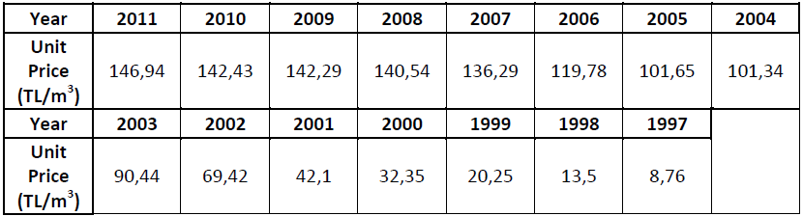

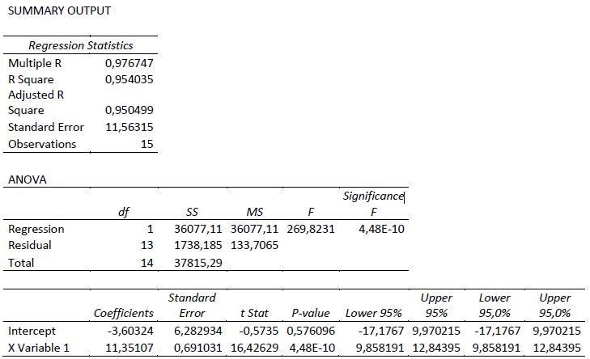

The equation obtained from the regression analysis gave the result of 250 TL/m3 for 2017

Current unit costs of rebar, excavation, tendon, formwork and pile driving are also found by regression analysis taking the prices of the book of Ministry of Environment and Urban Planning of Turkey as reference

The following estimation has been done only by based on the material costs and assumptions. The results is;

|  |  |  |  |  |  |  |
| --- | --- | --- | --- | --- | --- | --- |
|  | Volume (m3) | Area (m2) | Weight (tons) | Length (m) | Unit Price (Tl/unit) | Cost (Tl) |
| Excavation | 864 |  |  |  | 3,25 | 2.808 |
| Pier Column | 160,14 |  |  |  | 250 | 40.035 |
| Bridge Decks | 2661,06 |  |  |  | 250 | 665.265 |
| Rebars |  |  | 12,75408 |  | 1850 | 23.595 |
| Foundation | 864 |  |  |  | 200 | 172.800 |
| Pile Driving |  |  |  | 900 | 650 | 585.000 |
| Formwork |  | 9904,14 |  |  | 37,58 | 372.198 |
| Tendons |  | 7680 |  |  | 60 | 460.800 |
| Earthmoving | 57600 |  |  |  | 250 | 14.400.000 |
| Scaffolding | 22950 |  |  |  | 20 | 459.000 |
| Total |  |  |  |  |  | 17.181.501 |

# 9. References

* AASHTO Highway Standards
* Ardgermeli Beton ve Yeni Çözümler, Erhan Karaesmen
* “Design Guide for Improvement in Design and Construction in Turkish Bridge Engineering”, Middle East Technical University
* Eurocode2 Concrete Bridges – Design and Detailing Rules.
* Eurocode8 Design of structures for Earthquake resistance
* Freyssinet C-Range Post Tensioning System Guide.
* Karayolu Teknik Şartnamesi, Karayolları Genel Müdürlüğü.
* K. Terzaghi and R. B. Peck, “Soil Mechanics in Engineering Practice”, John Wiley & Sons, Inc.
* Price Book of the Ministry of Environment and Urban Planning
* R E. Hunt, “Geotechnical Engineering Analysis and Evaluations”, McGraw-Hill.
* R.F. Craig. “Soil Mechanics”, Van Nostrand Reinhold Company.
* Setra “Prestressed bridges built using the cantilever method” design guide.
* Turkish Earthquake Code 2007